______________________________________________________________________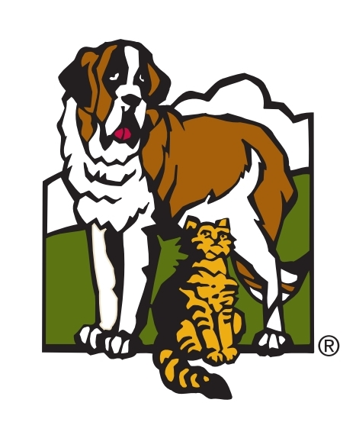

Virtual Meet-and-Greet Protocol

For Foster Families

Thank you for facilitating an online meet-and-greet for your foster dog!

This protocol is designed to help you navigate a meeting with a potential adopter safely and effectively, via a virtual platform . The potential adopters will also be given instructions on how these meetings will be conducted. It is your responsibility to make sure that your family and the adoptive family are following these guidelines. If you have any questions or concerns, please reach out to the Foster Dog Adoption team ([fosterdogadopt@orphansofthestorm.org](mailto:fosterdogadopt@orphansofthestorm.org)).

* You will set up a virtual meet-and-greet with the adopter, via a virtual platform that you both agree on. Examples are Zoom, FaceTime, WhatsApp, Skype, etc. A phone is a preferred method so you can navigate easily throughout the meeting.
  + The meet-and-greet must be at least 30 minutes long.
  + During the virtual meeting, please cover the following if possible:
    - On-leash behavior (walk the dog while another person films--please do not do both at the same time)
    - Any learned behaviors (sit, stay, come, etc.)
    - In-home behavior (where they sleep, where they eat, where they are when you are not home)
  + You will write up any notes on how the meeting went and send it to the [fosterdogadopt@orphansofthestorm.org](mailto:fosterdogadopt@orphansofthestorm.org) for the adoption team lead to review.
  + If the adopter is interested, you will direct the adopter to contact the foster adoption team to continue the adoption process.

|  |
| --- |
| Quick Meet-and-Greet Checklist:  * Do you have someone to film while you facilitate the meeting? * Do you have treats readily available? * Is the weather appropriate for a walk? * Are your internet service and media devices working properly (i.e. microphone, camera)? |