______________________________________________________________________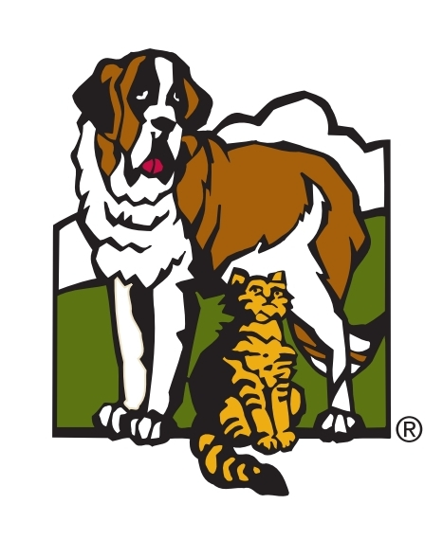

Virtual Meet-and-Greet Protocol

For Adoptive Families

Thank you for your interest in meeting one of Orphans of the Storm Animal Shelter’s foster dogs! This protocol is designed to help you navigate a meeting with a foster dog safely and effectively, via a virtual platform. The foster family will also be given instructions on how these meetings will be conducted. It is your responsibility to make sure that your family is following these guidelines. If you have any questions or concerns, please reach out to the Foster Dog Adoption team ([fosterdogadopt@orphansofthestorm.org](mailto:fosterdogadopt@orphansofthestorm.org)).

* The foster home will set up a virtual meet and greet with you via a virtual platform that you both agree on. Examples are Zoom, FaceTime, WhatsApp, Skype, etc.
  + The meet and greet will be 30 minutes long.
  + During the virtual meeting, the foster family will try to cover the following:
    - On-leash behavior
    - Any learned behaviors (sit, stay, come, etc.)
    - In-home behavior (where they sleep, where they eat, where they are when not home)
  + The foster home will write up any notes on how the meeting went and send it to the [fosterdogadopt@orphansofthestorm.org](mailto:fosterdogadopt@orphansofthestorm.org) for the adoption team lead to review. If you have any notes and/or questions about the dog you met online, please email [fosterdogadopt@orphansofthestorm.org](mailto:fosterdogadopt@orphansofthestorm.org).
  + If you are interested in adopting the dog, the foster family will contact the foster adoption team to continue the adoption process.

|  |
| --- |
| Quick Checklist to Prepare for Your Meet-and-Greet:  * Do you have any questions you may have prepared? * Is the entire family present for the meeting (if possible)? * Are your internet and media devices (i.e. microphone, camera, laptop) working properly? |