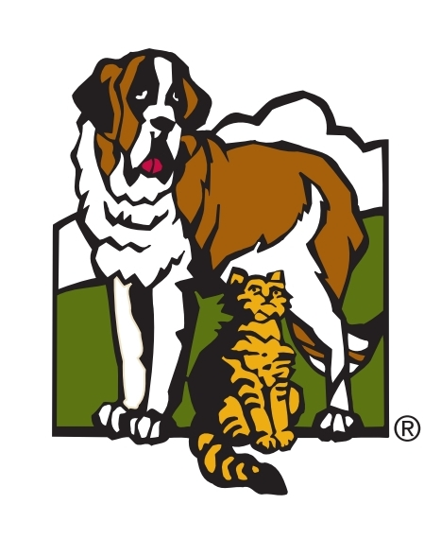
Protocol for Facilitating Adoption Directly from Foster to Adoptive Home

Upon receiving an adoption inquiry for a foster dog:
- The foster dog adoption volunteers will:
  - Direct the potential adopter to fill out an application if they have not already
  - Review the application for the specific dog they are interested in and look for any red flags. Red flags include:
    - If the adopter has other animals, be sure they are not interested in a “solo” dog.
    - If the adopter has children, be sure they meet the age limit requirements of the dog (ie. “over 5 years old” or “teenagers and older”)
    - If there is anything left blank that could be potentially concerning (this is to be followed up on through email with the adopter)
  - After reviewing, if the dog the adopter’s application does not match the criteria for that particular dog, the volunteer will direct them towards a more suitable dog.
  - If that particular dog has the “behavior consult needed” attribute on their ShelterLuv profile, cc the behavior team to set up a consult. (behaviorsupport@orphansofthestorm.org). The behavior team will help set up the rest from here.
  - If the adopter meets the criteria and no consult is needed, the volunteer will cc the foster home into the inquiry (emails found in the Foster Tracking Sheet) with the following email:
(Foster name here),
This person is interested in adopting your foster dog, (dog’s name here)! I am pulling you into this email to set up a time to do a meet-and-greet. Please reply directly to the adopter to set this up.
Thank you!
(Your name)
- The foster home will set up a meet-and-greet with the adopter.
  - The meet and greet must be at least 30 minutes long.
  - The foster home will write up any notes on how the meeting went and send it to the fosterdogadopt@orphansofthestorm.org for the adoption team lead to review.
  - The foster will direct the adopter to contact the foster adoption team to continue the adoption process.
- The adopter will let the adoption team know that they would like to proceed with the adoption.
  - The adoption team volunteers will star these emails for the lead to review.
- The foster adoption team lead will set up a time for either a phone adoption or an in- person adoption at the shelter.
  - If the dog has a behavioral or medical consult flag on their profile, we may require them to have an in-person adoption.
  - The dog will either be ready for pick up from the foster home or will need to go home through one of our hospitals.
- The foster will either:
  - Set up a pick-up time with the adopter and require the adopter show a copy of the adoption contract and an ID upon pick up. During COVID-19, we recommend wearing a mask and observing physical distancing as much as possible. --OR--
  - Bring the dog directly to the vet (if final vetting is needed), and the adopter will pick up directly from the vet.

