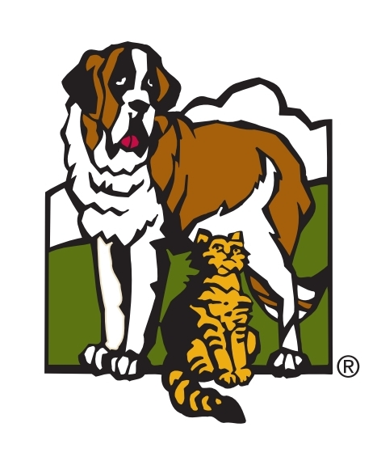
Adoption Checklist for Animals in Foster
____________________________________________________________________________________

Prior to Meet-and-Greet:

- Confirm application has been submitted and approved
  - Age 21 and older

- Confirm animal of interest is available

- Review all notes listed in ShelterLuv within animal’s profile, with the exception of those marked “private”
  - If an animal has a return form on file, return information must be disclosed in its entirety
  - Any medical notes must be disclosed in their entirety
  - Any behavioral notes must be disclosed in their entirely

During Meet-and-Greet:

- Foster checks and validates photo ID from applicant
- Photo of ID sent to Foster team via email

After Meet-and-Greet/Completing Adoption

- Confirm all medical, behavioral, and return form history has been discussed

- Discuss total costs
  - $90 adoption fee; unless animal and applicant qualify for the “Seniors for Seniors” program or a fee-waived event is occurring. If a fee-waived event, animals 6 months of age and older qualify
  - Final vetting charges; cost will be dependent on what the animal still needs

- Email adopter the following:
  - Adoption contract
  - Rabies certificate
  - Medical history

- Collect payment (credit and cash accepted)
  - Push payment text from ShelterLuv if virtual
  - Collect payment through ShelterLuv or cash if in person
  - Thank Adopter if donation is given during checkout

- If vetting is needed, confirm which partner vet Adopter would like to use
  - Ruth Helen Wolf
OR
  - Animal Medical Center of Skokie

- Coordinate drop-off for Foster to vet and pick-up for Adopter from vet
OR
- Coordinate drop-off at shelter for Foster, then pick-up for Adopter

- If vetting is not needed
    - Foster to coordinate pick-up from home
OR
- Coordinate drop-off at shelter for Foster, then pick-up for Adopter

- Provide adopter with resources
  - Cats
    - “First 30 Days” handout
    - “Cat Hazards” handout
    - “How to Find a Lost Cat” handout
    - “Multiple Cats Introduction” handout
    - “Kitten” handout
  - Dogs
    - “First 30 Days” handout
    - “House-training Dogs and Puppies” handout
    - “Separation Anxiety” handout
    - “How to Crate Train Your Dog” handout
    - “Dog Enrichment” handout
    - “Shy and Fearful Dogs” handout
    - “Dog Aggression” handout

- Thank adopter and ensure they know about:
  - 2 weeks of aftercare provided at our partnering vets, free of charge
  - If it isn’t the right fit, per adoption contract, they must be returned to Orphans of the Storm
  - How to register a microchip

