Greetings from Weatherford Parker County Animal Shelter!
It’s time for CLEAR THE SHELTER! The Weatherford Parker County Animal Shelter is having our annual CLEAR THE SHELTERS event THIS Saturday, August 15! We would like to reach out to our neighbors as we understand that last year there were some issues with our excited visitors and traffic. We are hoping to help alleviate some of those issues this year in your neighborhood to make this event exciting, fun and family friendly for both our guests at the shelter and for you!
Actions we are taking to prevent road blockages, traffic and parking issues caused from this event are:
- NO PARKING signs placed along Hickory lane
- Dedicated volunteers to help visitors into the shelter’s parking areas
- Bigger parking areas for our guests
- Requiring guests to park in our lots BEFORE being allowed into the event
We hope by taking these actions, we will be able to alleviate the issues with parking and traffic flow. We hope you will join us in this great adoption event and ask for your support and understanding with any issues that may arise during this event.
Below is the information regarding our event! We hope you will join us in the fun and festivities of many animals finding their forever homes!
Event Name and Location:
Clear the Shelters – Weatherford Parker County Animal Shelter
403 Hickory Lane, Weatherford, TX 76086
Event Date and Time:
Saturday, August 15, 2015 Event begins at 10:00 a.m. Event ends at 5:00 p.m.
Event Description:
This event was started last August (8/16/14) to bring the shelters in the DFW area together and to create relief for the shelters from the high intake summer months. This is a fee waived adoption event sponsored and promoted by NBC. This event has now gone national and will be celebrated from New York to California! Last year was the largest adoption event North Texas has ever seen, placing 2,217 animals in forever homes and our shelter saw over 500 guests!! This year, we hope to beat our record!
Be sure to follow us on Facebook, Twitter, and Instagram by following #ctsdfw and also on NBC channel 5!
Thank you!
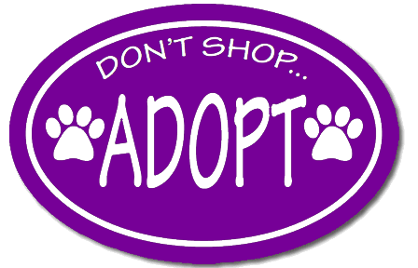
Weatherford Parker County Animal Shelter Staff and Pets!

