Note: Mark recent wounds in RED; mark scars in BLUE
Note: Ears removed from lateral views so wounds & scars under ears can be diagrammed

Veterinarian: _________________________________________________ Date: _________________
Law Enforcement Agency: ______________________________ Case #: ________________________
Dog ID #: ______________ Distinguishing Marks/Comments: ________________________________
___________________________________________________________________________________
___________________________________________________________________________________

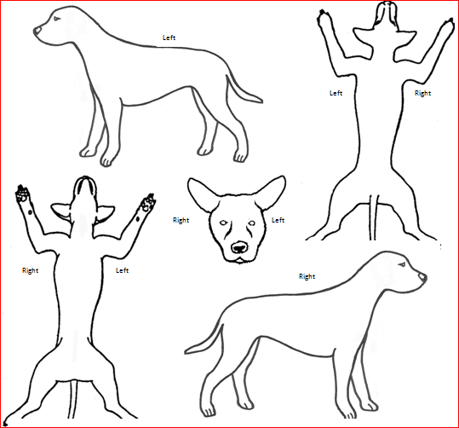
ASPCApro.org

