Survey Objective
To help animal welfare agencies identify what resources those who are relinquishing dogs or cats due to lack of some resource need to keep their pets. The survey questions and results are intended to inform the development or improvement of existing retention focused programs.
This survey is designed to be conducted as an in person interview.
Survey Data
- There are 3 survey questions that you will ask; all aimed at identifying need (see ASPCA Relinquishment Survey)
- You will aim to conduct a minimum number of surveys based on your organization’s 2015 owner surrender intake:

Yearly Owner Surrender Intake | Minimum Number of Surveys to Conduct
0 – 1,000 | 20 surveys
1,001 – 1,500 | 30 surveys
1,501 – 2,000 | 40 surveys
2,001 + | 50 surveys

If your organization only accepts dogs or only accepts cats then you would need to complete the surveys for that particular species. If your organization takes in a relatively equal amount of dogs and cats then you should aim to conduct an equal number of surveys on dogs and cats. For example, if your organization took in 1,200 owner surrendered animals (600 cat and 600 dog) in 2015 you would aim to conduct a minimum of 15 surveys on cats and 15 surveys on dogs.
  - Try to collect data over the course of at least 2 weeks (aim to connect with at least 2 relinquishers’ each day at the minimum).
  - Try to conduct your surveys during the week, over the weekend, and at different times of day to ensure a wide representation of potential situations experienced by those relinquishing
- Please conduct only one survey per person
  - If the person is there to surrender multiple animals, just choose one to survey, perhaps alphabetical by name
- Record day, time, and reason why people refuse to answer questions (see Refused document).

Survey Question Tip
- When asking open ended questions, like question #1 on the survey, we recommend writing exactly what the respondent says. Do not interpret what they are saying. Be as thorough and detailed as possible. The people reviewing the data for your program proposal may not be familiar with the circumstances.
An example of a mistake would be:
“She has a broken leg”.

There are at least two possible interpretations of this statement. These are both correct ways to record:

“My dog, Minnie, has a broken leg and is in pain. I can’t afford to take her to the vet”.
OR
“I, Mary, have a broken leg and can no longer take care of my dog, Minnie.”

Survey Process
Before you begin to conduct a survey, you will want to lay out the following ground work.
Step 1: Determine how you will collect survey responses
At the ASPCA we use Survey Monkey and QuickTap when doing survey work. Survey Monkey offers a free basic plan and QuickTap has a plan that starts at $19/month. If conducting surveys real time using a tablet, smart-phone, or computer Survey Monkey does requires Wi-Fi. With Quicktap you can conduct your survey in real time, without Wi-Fi, and upload when you reconnect with Wi-Fi. You can also create surveys for free with Google Forms and last but not least you can use paper and pencil and enter your results into a spreadsheet for easier analysis. In case of technical issues, it’s always a good idea to backup or have a clean copy of your survey data.
Step 2: Determine who will be conducting the surveys (staff and/or volunteers)
We recommend having the same one or two people conduct the surveys and that there is one supervisor or person in a leadership role overseeing the process. Regardless of who is conducting the surveys you will want to let your staff and volunteers know that survey work is happening and to provide them with a point person(s) should they be approached by someone wanting to surrender.
Who should you choose to conduct the surveys?
- Choose someone who can be impartial when listening to the answers of the people responding to the survey and won’t respond emotionally.
- Choose someone who can ask the questions in a straightforward, unbiased way; without suggesting to the person what their answers should be.
- Choose someone who can record the answers faithfully and someone you trust to make sure the answers are correctly entered into your data system
Step 3: Train staff member(s) and/or volunteer(s) who will be conducting surveys
- Review the ASPCA RFP
- Watch the recorded ASPCA Webinar
- Review and become familiar with the Survey Questions
- Review your Survey Tool Process (i.e. Survey Monkey, Quicktap, paper and pencil, etc)
  - For the recorded ASPCA Webinar we used Google Forms as our survey tool. Should your organization decide to use Google Forms please contact Lindsay Cicconi at lindsay.cicconi@aspca.org and she will email you the pre-built survey.
- Practice interviewing by surveying some staff or friends first
- Review survey results with your supervisor after the first 5 or so to see if it is going well; make adjustments as needed
Step 4: Identify where the surveys will be conducted, if possible, a private location in preferred
Step 5: Identify where you first interact with a person as they approach the shelter
This could be at the front desk, lobby, parking lot, intake area, or perhaps a combination of these. The survey questions are to be asked of those relinquishing/surrendering their pet. It will be important to identify these folks early on so that you can direct traffic and create an opportunity for a successful survey. A simple “What brought you here today?” can help you determine those coming to surrender versus something else.

Step 6: Determine your survey start date allowing enough time to reach your minimum survey requirement, analyze your survey results, create your program proposal, and submit your grant application by the due date.

Step 7: Start Surveying

After identifying those coming to surrender (see Step 5), your survey process might look something like this;

Step 8: Review Survey Data
Almost all survey tools allow the option to download your survey results into Excel and some provide automatic visual results through the use of charts; both of these options prove beneficial when analyzing survey data.
The following is an example of a chart from Google Forms. The chart is generated automatically after your survey results are submitted. The data in the chart is telling us that the primary reasons people relinquished was because the “pet had health problems they were unable to handle” and something “Other” than what was on the list. In Google Forms, in order to see the detailed text of “Other”, you would need to download the data to Excel or Google Sheets to complete your analysis.
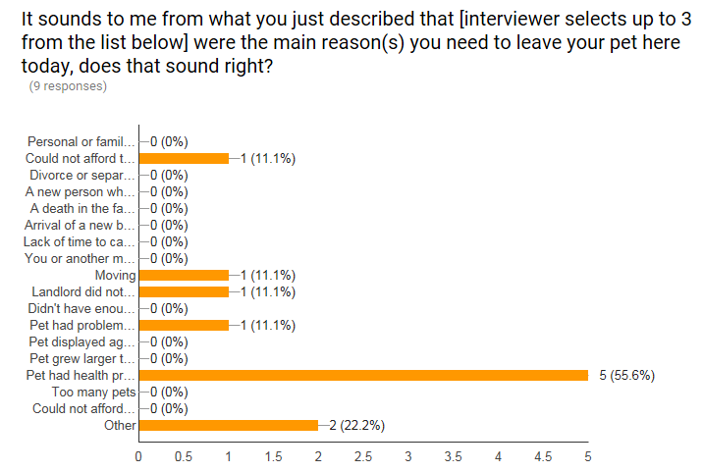
If you have questions about the survey process or data collection please contact Lindsay Cicconi at lindsay.cicconi@aspca.org
Step 9: Build Program Proposal
If you have questions about building your program proposal please contact Karen Medicus at karen.medicus@aspca.org
Step 10: Submit Grant Application
Please remember, your survey results must accompany your grant application. We recommend entering your survey results into an Excel file or other spreadsheet and uploading that file to the online grant portal. The first row of your spreadsheet would include the interview questions and the remaining rows would include your detailed survey results. See example below:


