*Article*

**Life with Pets Study: Lower income pet owners’ perception of pets’ quality of life**

**Elizabeth B. Strand1, Kristel Scoresby2, Hannah Walker1, Ana Hernandez3, Veronica Accornero3, Lori Messinger4, William Nugent4, Pam Linden1, Chesney Ward1, Haley Engelman1, Kristin Moore1, Margaret Slater 3**

| **Citation:** To be added by editorial staff during production.  Academic Editor: Firstname Lastname  Received: date  Revised: date  Accepted: date  Published: date    **Copyright:** © 2023 by the authors. Submitted for possible open access publication under the terms and conditions of the Creative Commons Attribution (CC BY) license (https://creativecommons.org/licenses/by/4.0/). |
| --- |

1 University of Tennessee, Knoxville Center for Veterinary Social Work; [estrand@utk.edu](mailto:estrand@utk.edu);

2 University of Kentucky, Lexington, Kentucky

3 Strategy and Research, American Society for the Prevention of Cruelty to Animals (ASPCA®), New York, NY 10128, USA

4 University of Tennessee College of Social Work

* Correspondence: estrand@utk.edu; Tel.: 865-974-8387

**Simple Summary:** Through a mixed methods research design, 50 low-income Spanish and English speaking pet owners shared their perspectives about their pets’ quality of life (QoL) in semi-structured interviews. Pet owners also rated their pets’ QoL on a 10 point analog scale. Results indicate substantial overlap between pet owners’ descriptions of the bond they have with their pets and how they describe their pets’ QoL. This finding is important for effectively measuring pet QoL which has substantial overlap with the human animal bond (HAB). Based on these findings future pet QoL research should incorporate reliable and valid measures of the HAB. This research also contributes pet owner QoL and HAB perspectives from lower income and non English speaking demographics.

**Abstract:** Perception of quality of life for cats and dogs of low-income Spanish and English-speaking pet parents attending problem focused or routine veterinary visits is an important area of focus for community based veterinary service providers. Using a mixed methods approach, 50 New York City based ASPCA pet parents completed semi-structured interviews as well as a survey about their perception of life with their pets. Quantitative results indicated that a single item 10-point scale measuring pet parent perception of their pets QoL did not differentiate between sample demographics at a statistically significant level. Qualitatively, pet parents consider both human animal bond (HAB) related and quality of life (QoL) related factors in their daily experience with their pets. Moreover, 60% of qualitative excerpts included both HAB and QoL themes and 40% were discretely HAB or QoL. When asked about pet QoL, some pet parents needed further clarification to understand the concept. Finally, overall pet quality of life literature does not reflect diverse demographic identities of pet parents or widely include reliable and valid measures of the human animal bond.

**Keywords:** pet quality of life; human animal bond; low-income pet owners

**1. Introduction**

Quality of Life (QoL) is a concept that has been discussed in healthcare since the mid 1900’s [[1–3]](https://paperpile.com/c/WA79Xt/M7mdF+ti5tW+PAtFL). Decision making related to QoL has been important in human and veterinary health care settings alike [[4]](https://paperpile.com/c/WA79Xt/XoXGZ). Many definitions of animal QoL have been proposed [[5–8]](https://paperpile.com/c/WA79Xt/nCMDv+69V96+Q3bFf+0jVPL) however, there is yet to be a single, widely accepted definition [[9,10]](https://paperpile.com/c/WA79Xt/JSqAc+BYVdT). Additionally there is evidence that the human animal bond (HAB) influences pet owners' perception of their pets QoL [[11]](https://paperpile.com/c/WA79Xt/sXVSZ). How pet owners perceive and give meaning to their pets behaviors is subjective in nature [[12]](https://paperpile.com/c/WA79Xt/JJ1tG). This can make it difficult to establish reliable measures of pet QoL for the purposes of medical care decision making [[10]](https://paperpile.com/c/WA79Xt/BYVdT). Lastly, little attention has been paid to how low income pet owners may experience or describe their pets’ quality of life [[13,14]](https://paperpile.com/c/WA79Xt/2NUcJ+f60N6).

**Quality of life and understanding medical outcomes**

Some argue that animal QoL is synonymous with animal “welfare” [[4,8,15–17]](https://paperpile.com/c/WA79Xt/XoXGZ+UtHIa+sjjqA+OzbNa+0jVPL) and much like the QoL definition, there is no single way that animal welfare is defined [[18,19]](https://paperpile.com/c/WA79Xt/BlXFA+UYF6i). Traditionally, animal welfare has focused on preventing abuse and neglect, whereas animal QoL has focused on the thriving well-being of animals, including psychosocial [[8,20,21]](https://paperpile.com/c/WA79Xt/iCr4Z+Gu8q9+0jVPL) and emotional well-being [[20,21]](https://paperpile.com/c/WA79Xt/Gu8q9+iCr4Z). In most of human healthcare QoL is assessed by self report. In veterinary medicine, much like pediatric medicine, a pet owner is the proxy reporter of pet QoL. Therefore, veterinarians must rely on pet owners' assessments of pet QoL for determining if the animal’s welfare is acceptable, what medical care is needed, and also if an animal is coming to the end of its life. A key difference between animal welfare and QoL is that QoL encompasses both animal welfare and the improvement of animal well-being, including emotional well-being [[22,23]](https://paperpile.com/c/WA79Xt/1ewwn+Nbhk3). Pet owner’s emotions and perspectives about their pets QoL in times of illness has important implications for both pet owners and veterinarians [[24]](https://paperpile.com/c/WA79Xt/s01WD).

**The human animal bond, quality of life, and pet welfare**

Many QoL scales have been proposed. However, they are frequently limited by only assessing a single dimension, such as a specific disease or species, which is not representative of general veterinary practice [[9,25]](https://paperpile.com/c/WA79Xt/JSqAc+6VwFv). Studies that have specifically researched QoL dynamics, such as emotional well-being [[6,20,21]](https://paperpile.com/c/WA79Xt/69V96+iCr4Z+Gu8q9) operationalize QoL domains as vitality, comfort, and emotional wellbeing. Freeman et al [[26]](https://paperpile.com/c/WA79Xt/Pi7Tp) describe QoL as physical, mental, emotional, and social functioning. Tatlock et al. [[27]](https://paperpile.com/c/WA79Xt/EPaco) includes physical and non-physical factors in their description of QoL. In a recent systematic scoping review of nine measurement tools assessing QoL, Fulmer [[10]](https://paperpile.com/c/WA79Xt/BYVdT) reported that common factors across assessments included activity level, desire of interaction, and appetite of the pet. What was not common across measurement tools was an assessment of the emotional attachment to the pet and how it affected QoL, although the author recognized this was an important facet of understanding QoL.

**Low income pet owners and access to veterinary care**

There are approximately 19 million pets living with families whose income level is below the United States (US) poverty line [[28]](https://paperpile.com/c/WA79Xt/qfOLD). Although research attention to the topic is growing [[14]](https://paperpile.com/c/WA79Xt/f60N6), traditionally research exploring pet companionship for low-income families has been limited. Rauktis et al [[29]](https://paperpile.com/c/WA79Xt/aujhR) suggest that low income pet owners enjoy the same pet-related advantages as income secure pet owners, including companionship, unconditional acceptance, and decreased social isolation. Despite potentially high levels of happiness and emotional investment, obtaining veterinary medical care for a pet may be limited when financial resources are scarce [[14]](https://paperpile.com/c/WA79Xt/f60N6). LaVallee et al [[13]](https://paperpile.com/c/WA79Xt/2NUcJ) identified five common barriers to access veterinary care: (1) the cost of veterinary care, (2) accessibility of care, (3) impaired veterinarian-client communication, (4) culture/language barriers, and (5) lack of client education. They suggested that more research is needed on the effectiveness and efficiency of community medicine initiatives.

The efficacy of community medicine initiatives that serve low income families is influenced by pet owner perceptions of a pet’s QoL and the human animal bond, both of which affect pet owners’ medical decision making [[9,13]](https://paperpile.com/c/WA79Xt/JSqAc+2NUcJ). For example, Rauktis et al [[14]](https://paperpile.com/c/WA79Xt/f60N6) presented the case of a single mother who stated that while she knew her daughter would never forgive her if they had to give up the pet or put it down because they couldn't afford an operation, they could not afford to put their finances at greater risk if the family pet needed back surgery. Another important term for the ways that family circumstances such as these affect the human animal relationship is called Family Quality of life (FQoL) [[30]](https://paperpile.com/c/WA79Xt/qPVmi). The experience of poverty has been shown to have associations with human neurodevelopment [[31]](https://paperpile.com/c/WA79Xt/upUuH) and can be associated with attentional bias toward threat [[32]](https://paperpile.com/c/WA79Xt/ejUYX). This attentional bias, the over tendency to observe external stimuli as threatening, could have an impact on how pet owners perceive their pets health and behavior. Serpell [[12]](https://paperpile.com/c/WA79Xt/JJ1tG) also argues that the subjectivity of the human animal bond makes it difficult to determine animal welfare from an owner’s perspective. An earlier study of food insecurity in low-income households with animal companions found that food bank pantry volunteers believed that clients who did not have pet food were giving their meat and fish to their pet because owners viewed their companion animal as a family member and were committed to keeping them healthy [[29]](https://paperpile.com/c/WA79Xt/aujhR). Arrington and Markarian [[28]](https://paperpile.com/c/WA79Xt/qfOLD) point out that like human food deserts, there are animal resource deserts where entire neighborhoods lack veterinarians or pet supply stores. With no resources available, standard wellness care is difficult to obtain [[28]](https://paperpile.com/c/WA79Xt/qfOLD). The experience of poverty and how this impacts brain development [[31]](https://paperpile.com/c/WA79Xt/upUuH), and perception of self efficacy [[33]](https://paperpile.com/c/WA79Xt/1TeEi) are important considerations in understanding how the nature of human animal bond may impact pet owners' perspectives of pet QoL.

The present study explored perception of QoL for Spanish and English speaking pet owners of dogs or cats who were seeking routine or problem focused veterinary treatment for their pets. The first aim was to explore pet owner perceptions of pet QoL. The second aim was to explore differences in subjective QoL scores based on species (cat or dog), whether the pet had a medical problem or was receiving routine care, and the preferred language of pet owners (Spanish or English).

**2. Materials and Methods**

The present study analyzed data from a convergent mixed methods study comparing how pet owners and veterinarians define pet QoL (see Fig. 1). The data for this manuscript focus on pet owner perspectives only.

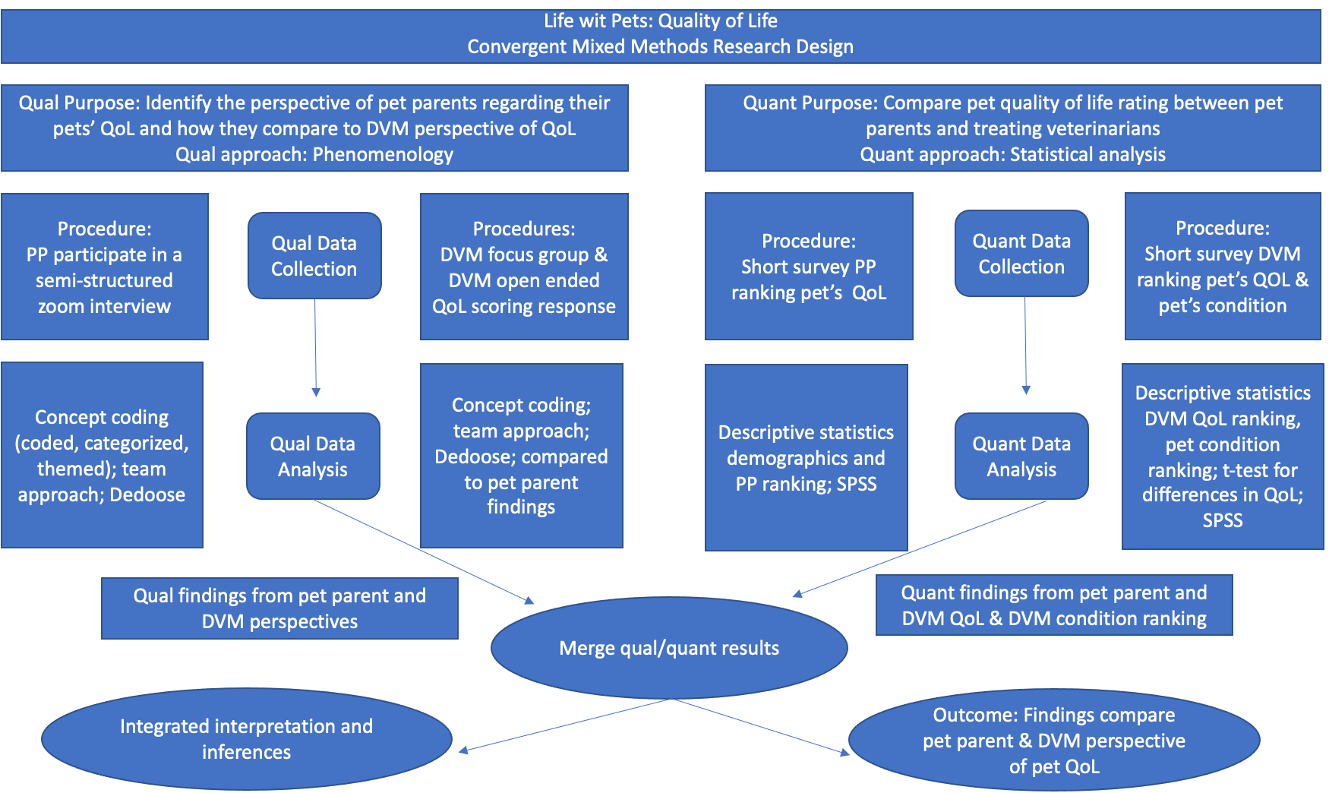

Fig. 1 Research procedural diagram

***Participant Recruitment***

Data were collected from English and Spanish speaking pet owners of dogs or cats who utilized services at two ASPCA locations (a community clinic and a veterinary hospital) in New York City (NYC) between July 20, 2021 and September 28, 2022. To access ASPCA services pet owners must live in New York City and have a self-reported annual income under $50,000. The ASPCA community clinic offers subsidized preventatives (e.g. vaccines and parasite control) and basic medical care (e.g. skin condition care, respiratory illness treatment, medical grooming, etc). The hospital provides subsidized urgent or emergency services for qualifying medical conditions with good prognosis, such as orthopedic surgery. Patients with poor prognoses and comorbidities, such as cancer or diabetes, are not eligible for care but may be treated palliatively at low cost to the owner. In appropriate circumstances, no cost euthanasia may be offered. Pet owners were contacted by phone and text message inviting them to participate in the study after they called to make a veterinary appointment at the ASPCA. If they agreed to be in the study, pet owners participated in a semi-structured interview via Zoom approximately 1-5 days before the pet veterinary appointment at the community clinic or between treatment and recheck appointments at the ASPCA hospital.

***Data collection***

Six trained research assistants (four English speaking and two bi-lingual Spanish/English speaking) conducted individual semi-structured interviews with pet owners. Interview data were collected via Zoom web-based meetings.The use of online technology such as telephone and Zoom-based interviews have been noted as different but equal methods for data collection [[34–38]](https://paperpile.com/c/WA79Xt/glLf0+K1qIR+1QPre+9qjXD+tDRWI) in qualitative research. Semi- structured interview questions focused on pet owners’ experiences living with and caring for their pets generally (*“What is a day like for your and your pet?*”), as well as their perception of their pets’ QoL (*“How would you describe your pet’s quality of life?”*). The interview included a 1-10 point Likert scale figure with 1 indicating “terrible” QoL and 10 indicating “excellent” QoL. Pet owners were asked to describe what they would observe if their pet's QoL was a 1, 5, and 10. At the conclusion of the interview, pet owners were provided a survey link to complete demographic questions, reasons for the upcoming veterinary visit, and a numerical ranking of their own pets’ current QoL.

***Data Analysis***

Pet owner interviews were analyzed using an interpretative phenomenological analysis framework. A coding team of four animal-related professionals (one of whom was fluent in Spanish) and six social work professionals (one of whom was fluent in Spanish) utilized a concept coding process that occurred in multiple steps. Concept coding identifies a word or phrase that is an overall “big picture” analysis of the data [[39]](https://paperpile.com/c/WA79Xt/cmyTg). First, a priori codes were identified in exploratory pilot data by the research team. Using Dedoose Version 9.0.17, (2021. Los Angeles, CA: SocioCultural Research Consultants, LLC [www.dedoose.com](http://dedoose.com/)), the research team applied codes to all of the qualitative data. Each pet owner interview was coded by two researchers. When disagreement between codes occurred, a third researcher coded the interview. The coding team met frequently throughout the analysis to discuss codes until consensus was reached. After all data was coded, the findings were organized in categories, leading to the development of themes and sub themes.

Descriptive statistics were used to report sample demographics. A non-parametric independent-samples median test was used to compare QoL scores from the 10 point scale between dogs and cats, Spanish and English speaking pet owners, and problem focused versus routine pets visits. SPSS v. 26 was used for quantitative data analysis (IBM Corp. Released 2019. IBM SPSS Statistics for Mac, Version 26.0. Armonk, NY: IBM Corp).

**3. Results**

3.1 *Sample.* In all, 50 cases were analyzed. Fifty six percent (n = 28) of pet owners reported their primary language as English and 44% (n = 22) Spanish. Nearly three-quarters (74%, n = 35) self-identified as Hispanic (N=35). Fifty-four percent (N=27) of the pets were dogs and 46% (n = 23) were cats. From the pet owners’ perspective, 56% (N=28) of appointments were routine visits and 44% (n = 22) were problem visits (see Fig 2). Eighty percent (N=40) of visits were in the community clinic and 20% (n = 10) were at the ASPCA hospital. More than half of pet owners (52%, n=26) reported an annual income below $15,000 (see Table 2).

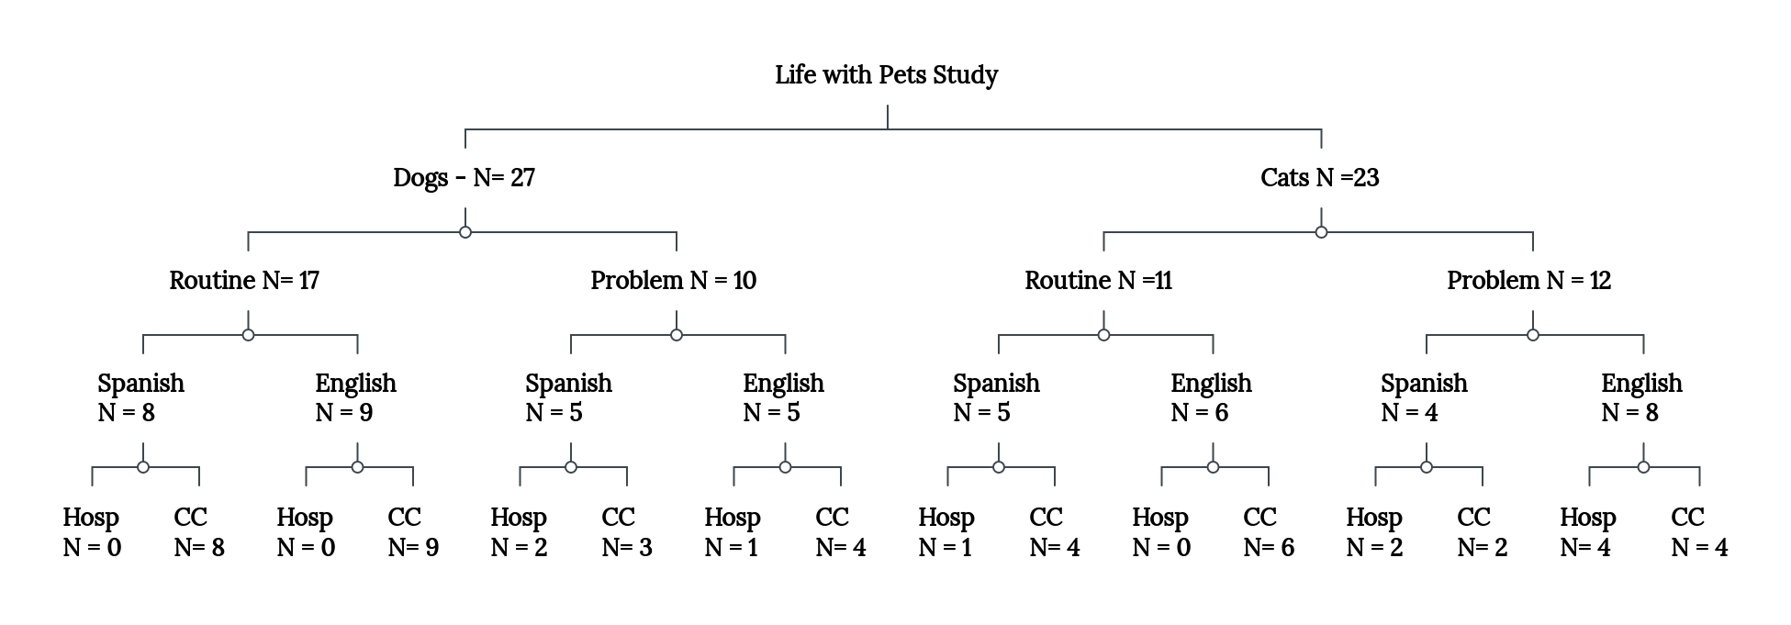

Fig 2. Diagram of total sample per subgroup n’s

| Table 1: Demographics of Study Population | | | |
| --- | --- | --- | --- |
| **Variable** | | ***N = 50*** | **Percent** |
| Age of Pet Parent | |  |  |
|  | 21-28 | 8 | 16% |
|  | 29-36 | 15 | 30% |
|  | 37-44 | 6 | 12% |
|  | 45-52 | 8 | 16% |
|  | 53-604 | 9 | 18% |
|  | 61+ | 4 | 8% |
| Gender of Pet Parent | |  |  |
|  | Female | 42 | 84% |
|  | Male | 6 | 12% |
|  | Non-Binary | 1 | 2% |
|  | Missing | 1 | 2% |
| Race/Ethnicity of Pet Parent 1 | |  |  |
|  | Reported Hispanic Ethnicity Only | 28 | 56% |
|  | Black | 9 | 18% |
|  | White | 6 | 12% |
|  | Reported Country of Origin | 5 | 10% |
|  | No response | 2 | 4% |
| Primary Language | |  |  |
|  | English | 28 | 56% |
|  | Spanish | 22 | 44% |
| Annual Income of Pet Parent | |  |  |
|  | Less than $15,000 | 26 | 52% |
|  | $15,000-$34,999 | 12 | 24% |
|  | $35,0000-$49,999 | 8 | 16% |
|  | $50,000-$74,999 | 1 | 2% |
|  | $75,000-$99,999 | 1 | 2% |
|  | Not sure | 2 | 4% |
| Number of People in Household Including the Pet Parent | |  |  |
|  |  |  |  |
|  | 1 | 9 | 18% |
|  | 2 | 17 | 34% |
|  | 3 | 10 | 20% |
|  | 4 | 3 | 6% |
|  | 5 | 7 | 14% |
|  | 6+ | 4 | 8% |
| Pet Type | |  |  |
|  | Cat | 23 | 46% |
|  | Dog | 27 | 54% |
| Location of Visit | |  |  |
|  | Clinic | 40 | 80% |
|  | Hospital | 10 | 20% |
| Type of Visit | |  |  |
|  | Problem visit | 22 | 52% |
|  | Routine visit | 28 | 48% |
| 1 This question was open ended resulting in some pet parents sharing their ethnicity but note race, and others sharing the country of origin but not race or ethnicity | | | |

3.2 *HAB and QOL Themes;* Qualitative analysis resulted in 2,720 excerpts with 32 codes across 50 semi-structured interviews. Excerpts could have more than one code applied. Results of the qualitative analysis of these excerpts produced two main themes and four sub-themes. Two sub themes were focused on the QoL: animal mental/physical condition (N=5 sub codes) and daily rhythms and habits (N=8 sub codes). Two sub-themes were focused on HAB: nature of attachment (N= 8 sub codes), and human/pet family pet characteristics (N=5 sub codes). The qualitative analysis also produced six codes that related to a 10 point scale shown to participants about perspectives on QoL.

3.2.1 QoL Theme

* Animal mental and physical condition sub-theme; There were 1,184 excerpts regarding the animal’s mental and physical condition. Pet owners commented on their pets’ behavior (n= 552) “*Then, he follows me actually. That’s what he does, follow me everywhere I go,”* health concerns (n= 495) *“...he didn’t want to eat, he didn’t want to drink water, he was going to the bathroom very often. Those were the first symptoms we saw when he was sick,”* pet preferences (n= 221), *“She have her hiding spots. She just chills out in there, until she's ready to come out for her food,”* hygiene (n = 132), “*I brush him, I bathed him, I brushed him. I have him nice and ready for tomorrow. He likes to be bathed*,” pets’ breed (n=35), “*She’s a German Shepherd and terrier.”*First bullet;
* Daily rhythms and habits sub-theme; There were 1,099 interview excerpts that focused on pets’ daily rhythms and habits. Pet owners commented about their pets’ nutrition (n= 449), *“She doesn’t want to eat sometimes, there’s something about the food,”* play (n= 321), “*She likes to play with her little toys. She grabs them and she just tossed, throws them around,”* sleep (n=227), *“Right now, she is asleep. She sleeps a lot. She sleeps during the day but she doesn’t have specific sleep times. She’s quiet at home and she falls asleep,”* exercise (n= 150), “*He used to run around a little bit more than he used—than he does now, just randomly get the cat zoomies,*” elimination behaviors (n= 145), *“She used to only pee when we took her outside, but later she started going here in the apartment a lot,”* undesirable behavior (n= 135), *“He had a scratching post and he was not using it. He was scratching everything else that was wood except that,”* vocalization (n = 121), *“He has separation anxiety, so sometimes when I leave he barks a lot,”* training (n= 70), *“She’ll see wires…She’ll bother them, but I’ll tell her somethin’ without even touching her, and she knows that that’s the wrong thing to even be doin’, so she’ll just walk away.”*

3.2.2 HAB Theme

* Nature of attachment sub-theme; There were 1,173 excerpts that focused on the nature of attachment between pet owner and pet. Pet owners commented about the naming and familial roles of their pets (n= 537), *“I’m very grateful for having my son [Tommy]. I love it very much. He is my life; he is my life,”* empathic interpretation/action of pet emotion (n = 470), *“Well, I think that he feels happy, because when we get home he wags his tail, he likes to be with us. If we leave, he looks for us, and everyone wants to be with him,”* physical touch (n = 206), *“And I like her above all because she’s very affectionate; she lets everyone pet her. Especially since I have a little child in here. It’s good to have a pet like that,”* pet owner protectiveness (n= 203), *“She had a hard life and I make it my goal for her to never have a hard life ever again,”* benefits of being a pet owner (n=130), *“You forget about stuff—you’re running around, for whatever reason your stress level is high, but she has helped me relieve my stress because she keeps me busy and playing with her toys and I feel like a kid again. I think it would be good if people could keep pets to feel much better,”* sacrifices made for the pet (n = 86), *“I’ve been selling my jewelry, things I had at home, in order to cover… the food and grooming for the dogs,”* emotional support from the pet (n = 68), *“He’s actually like my—my little dogs are—my little dogs are certified, and they’re my emotional support dogs,”*  and finance (n = 51) *“we split the cost of buying the cat and everything. We end up splitting the financial burden of certain things. Especially doing these emergency vet visits and things, I've definitely had assistance from him on that front.”*
* Human-pet family characteristics; There were 874 excerpts that focused on human/pet and family characteristics. Pet owners remarked about seeking professional help for their pet (n= 300), *“She doesn’t really have pain or anything. It’s just I just noticed that the spots are there, so I don’t know 100 percent if something’s causing them or if they’re like a birthmark of some sort, so I just wanted to take her again just to be 100 percent sure,”* having multiple pets (n = 222), *“I actually have two little dogs,”* having multiple people living in the home (n = 219), *“I have three children and he brings a lot of joy to our family,”* the pet being rescued (n = 134), “*Yes, I got Tommy because it happens that in my grandmother’s building there was a man whose cat gave birth all the time. Then, one day, I grabbed Tommy. And this is Tommy, in the basement where my grandmother lives,*” and, history of their own pet keeping (n = 122) *“I've had dogs, fish, hamsters, [laughter] that type of good stuff.”*

*3.2. 3* Overlap and discrete HAB and QoL Excerpts; There were 1,731 excerpts coded with QoL themes and 1,697 coded with HAB themes. Sixty percent of excerpts (n = 1033) were coded with both QoL and HAB themes. The codes with the strongest co-occurrence were animal behavior empathic interpretation/action of pet emotion (n= 187), health concerns x empathic interpretation/action of pet emotion (n= 146), health concerns x professional help seeking (n= 154), and naming and familial interaction x nutrition (n=116). Forty percent (n = 698 of 1731) of QoL excerpts were discrete with no HAB codes and 39% (N = 664 of 1697) of HAB excerpts were discrete with no QoL themes (see Figure for discrete sub-theme excerpt counts). The child themes where more than 50% of excerpts were discretely coded as QoL were: breed 66% (n= 23 of 35), undesirable behavior 56% (n = 76 of 135), training 54%(n= 38 of 70), and sleep 53% (n= 121 of 227). The child themes where more than 50% of excerpts discretely coded as HAB were: history of pet keeping 86% (n= 105 of 122), rescue pet 71% (n=95 of 134), emotional support 57% (n= 39 of 68), benefits of pet ownership 53% (n= 69 of 130), and finance 53% (n= 27 of 51). (See Fig 3)

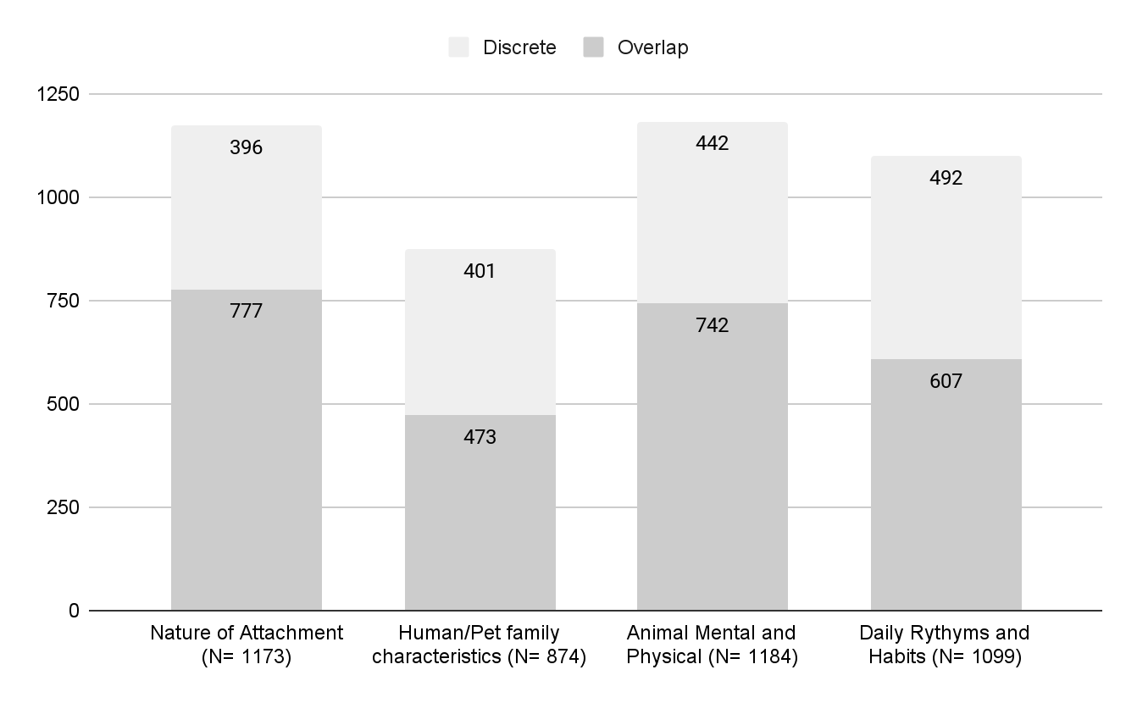

Fig 3. Overlap and Discrete QoL and HAB Sub-Themes

3.3 *Quantitative Differences in scores on 10 point QoL scale*. Mann-Whitney U tests were

conducted to compare median pet owner’s QoL scores between dogs (n= 27) and

cats (n= 23), routine visits (n= 28) and problem visits (n = 22), community clinic

(n=40) and hospital (n=10), primary language Spanish (n = 22) and primary language

English (n= 28), and Hispanic (n =35) and non-Hispanic (n=13) pet owners. There

were no statistically significant differences between the medians of QoL for dogs

and cats (U = 306.50, p = .93), routine and problem visits (U = 224.00, p = .08), for

community clinic and hospital appts (U = 137.00, p = .10), primary language Spanish

and primary language English (U = 217.50, p = .06), and Hispanic and Non-Hispanic

pet owners (U = 193.50, p = .40). A Kruskal-Wallis test was conducted to compare

the QoL median scores across different levels of household income. The results

indicated no statistically significant difference between the medians of QoL across

different levels of household income (H = 3.711, df = 5, p = .60) (see Table 2).

| Table 2. Median QoL Scores for Pet Owners (PO) | | |
| --- | --- | --- |
| Variable (N=) | Median PO QoL (SD) | Min-Max QoL |
| Total Sample (N=50) | 9.5 (1.25) | 5-10 |
| Animal |  |  |
| Dog (N=27) | 10 (1.37) | 5-10 |
| Cat (N=23) | 9 (1.11) | 7-10 |
| Visit type |  |  |
| Routine (N=28) | 10 (1.33) | 7-10 |
| Problem (N= 22) | 9 (1.11) | 5-10 |
| Location |  |  |
| Community Clinic (N=40) | 10 (1.27) | 5-10 |
| Hospital (N = 10) | 9 (1.07) | 7-10 |
| Primary Language |  |  |
| English (N=31) | 9 (1.23) | 6-10 |
| Spanish (N=19) | 10 (1.21) | 5-10 |
| Ethnicity |  |  |
| Hispanic (n= 35) | 10 (1.30) | 5-10 |
| Non-Hispanic (N = 13) | 9 (.1.14) | 7-10 |
| Missing (N=2) | 9 (1.4) | 8-9 |
| Household Income |  |  |
| Less than $15,000 | 9 (1.15) | 6-10 |
| $15,000-$34,999 | 9.5 (1.56) | 5-10) |
| $35,000 to $49,999 | 10 (1.18) | 7-10 |
| $50,000 to $99,999 | 10 (0) | 10 |
| Unsure | 9 (1.41) | 8-10 |
| Household Income Dichotomized |  |  |
| Under $15,000 | 9 (1.16) | 6-10 |
| $15,000- $49,000 | 10 (1.14) | 5-10 |

3.4 *Qualitative differences in QoL questions.* Pet owners were shown a 1-10 scale ranging

from 1 = “terrible” and 10 “excellent” (see Figure 4). They were asked to describe what

their animal would be at a level 1, level 5, and level 10. Discrete QoL excerpts across 1,5,

and 10 included elimination behavior, exercise, nutrition, play, sleep, health concerns,

and hygiene. Discrete HAB excerpts across 1,5, and 10 included empathic

perception/action toward pet emotion (see Table 3). When asked about the QoL of their

pet, some pet owners struggled to understand the question *(e.g. “What you mean, by the*

*way, what you mean by quality of life, though? In what way?” “Are you referring to the way she*

*feels?” “Health-wise or just in general?”).* Pet owners were given 0-3 prompts to help clarify

what was meant by QoL. Dog owners needed more prompts than cat owners. Those with

income under 15k and whose primary language was English also needed more prompts

(see Figure 5).

| Pet Quality of Life | | | | | | | | | |
| --- | --- | --- | --- | --- | --- | --- | --- | --- | --- |
| 1 | 2 | 3 | 4 | 5 | 6 | 7 | 8 | 9 | 10 |
| Terrible Excellent | | | | | | | | | |
| Fig. 4 QoL Scoring Tool | | | | | | | | | |

| Table 3. QoL1 at 1,5,10 applicable child codes and example excerpts ꜛ | | | |
| --- | --- | --- | --- |
| Child codes | QoL 1 (N of and example excerpt) | QoL 5 (N of and example excerpt) | QoL 10 (N of and example excerpt) |
| QoL Elimination behavior | N = 5 excerpts | N=3 | N = 1 |
|  | *I think that if he was in a really bad place, I think I would probably notice him peeing everywhere too.* | *They don't have a dog life. They just stay in the apartment all day, or in the house all day. All they have, they put 'em in the backyard, and they don't take 'em anywhere. Go do your need in the backyard, and that's it.* | *She wouldn’t have diarrhea and stuff like that, so no health issues I would say at a 10* |
| QoL Exercise | N=17 | N=5 | N=5 |
|  | *Being neglected, like not bein' taken care of the way he's supposed to be. That's a one. Lettin' him go hungry. Not walking him. Not socializin' him. That's a one.* | *I would see him sad, dispirited, maybe? Restless. Let’s say, maybe he wouldn’t eat. Uh-huh. He wouldn’t be very active.* | *I really think—and he would probably have more space. He'd probably be running around a little more.* |
| QoL Nutrition | N = 19 | N = 18 | *N = 9* |
|  | *Well, starving and such.* | *Not a lot of energy, but yet eating. Not being that active. Eating, but not as much.* | *It would be an excellent level, he would have all the amenities he needed, he would eat well, he would behave well with people* |
| QoL Play | N=5 | N=9 | N=11 |
|  | *Just very triggered I would say if she had a one quality of life. Not wanting to play.* | *He probably would not be very interested in playing with the things that he normally likes to play with.* | *A 10 would be—yeah, excellent. Runnin’ around, jumpin’ on the couch, jumpin’ on the other animals, just doin’ stuff.* |
| QoL Sleep | N=3 | N=3 | N=3 |
|  | *A one will say his energy will be draining. He would be sleeping most of the time. He’ll be sad, I mean, one sounds horrible, so, yeah.* | *That’s what it is, when she’s not feeling the way she should, she becomes—she goes in her solitary, she has a bed, she’ll go in her bed* | *Yes, she’s playful, she plays with her other siblings. She’ll sleep with the other ones.* |
| QoL Health Concerns | N=23 | N =19 | N =9 |
|  | When she first came to me, she was full of fleas, underweight, shivering, homeless, terrified. Also that one Friday night when her wound had gotten so bad, she couldn't walk. She was limping. She still had an appetite, which was crazy. Friday, that one Friday night was absolutely terrible. | *I think probably in terms of her weight, she wouldn’t probably be as solid as she is and active, and she wouldn’t have her appetite. I think she would probably be—she would have an appetite but not much, and she wouldn’t be very active at all. She would be doing a lot of sneezing and having breathing issues so much, that you hear, like when a person has bronchitis, that’s how she was going for a minute.* | *Well, she wouldn’t have any issues with her lungs or upper respiratory. She wouldn’t have that. She wouldn’t have that cyst on her head. She wouldn’t have issues in terms of her sneezing or wheezing or anything like that. She’d probably be in more mischief than normal, than she normally is [laughter], a whole lot more, be a whole lot worse than what she gets into. She’d really be tearing up the house and stuff like that. Her condition would be great. Her appetite would be there. She wouldn’t have diarrhea and stuff like that, so no health issues I would say at a 10.* |
| QoL Hygiene | N =5 | N= 3 | N =2 |
|  | *I think she would be dirty, poorly fed, I don’t know, sick.* | *they’re problematic with bathing* | *I can’t always take him to get him trimmed, because my dog is one of those that needs grooming. We used to pay but now we bought the machine and we do it. I only take him to get his nails cut. That’s why I say that for me, a 10 is when someone provides the dog with a lot of care* |
| HAB Empathic perception/action based on pet emotion | N=8 | N=5 | N=4 |
|  | *Honestly, that would be quite bad having a dog when people even abuse them, they hit them. There are people who have dogs only to breed them and for me that is quite awful.* | *Mm, they wouldn’t give him affection, they wouldn’t take him to the doctor. That would be a bad life, because you have to take him to the doctor. There are people who give their pets love, they give their pet affection, but they don’t take them to the doctor, and they need to go to the doctor.* | *A dog that's well fed. A dog that is well taken care of. A dog that is taken to the vet for his shots, and a dog that is watched over and taken out to activities. My dogs, they went to the Pride Parade.*  *They had fun. A dog that has fun. A dog that is allowed to be a dog and not expectin' them to be like little babies, little kids, and behave like little kids. They are dogs at the end of the day, and they have to be—and they count on the person. They count on me, and I have to be there for them because they didn't ask me to bring 'em in. Now they count on me, and I have to be there. That's a 10 for a dog. A dog that all his needs are met.* |
| ꜛ Pet owners were shown Figure 3 with 1= Terrible QoL and 10 = Excellent QoL and asked to describe there pet at a 1, a 5, and a 10 | | | |

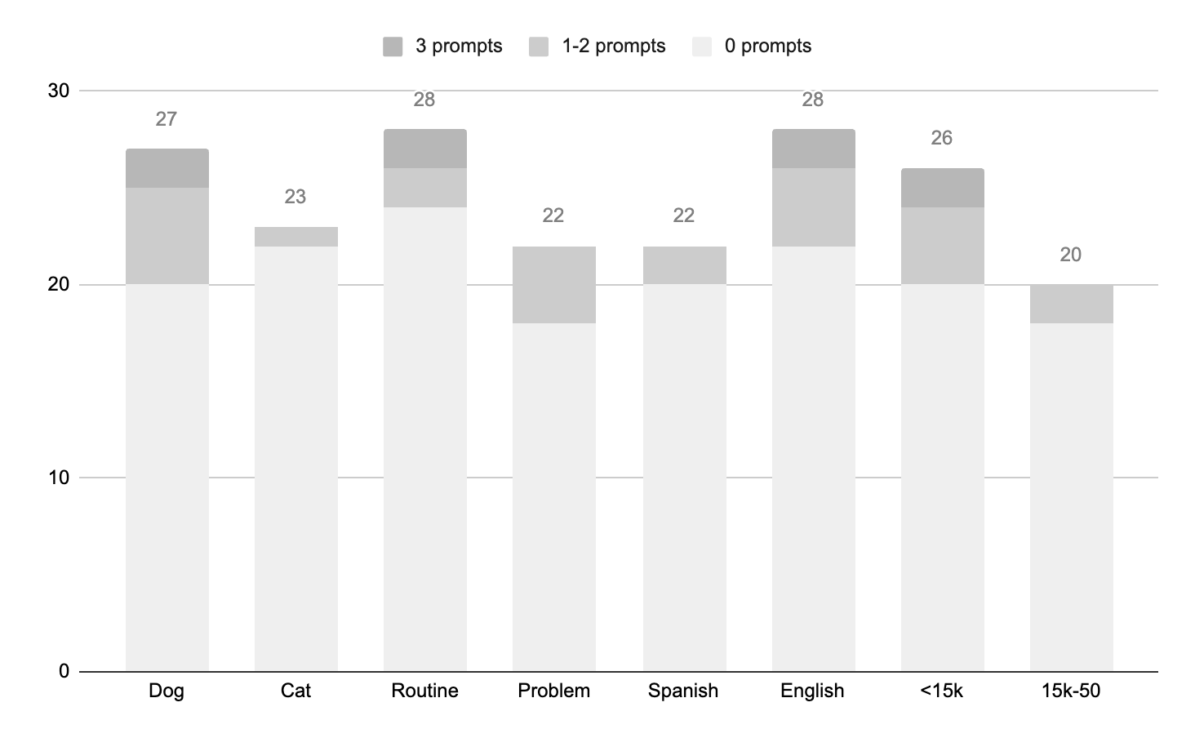Fig. 5. Number of clarifying prompts needed for QoL question

**4. Discussion**

Our findings are consistent with previous research that found that pet owners often expressed their loving feelings about their pets and described human-like emotions and behavior for their pets [[22]](https://paperpile.com/c/WA79Xt/1ewwn). Our study also confirms [[40]](https://paperpile.com/c/WA79Xt/cWcay) finding that pet owners focus on the familial nature of their pet relationships and empathic interpretation/action of their pet’s emotions. Our results further support current literature regarding the multifaceted concepts that are taken into consideration when determining QoL, including physical factors and the bond to the pet [[11,41]](https://paperpile.com/c/WA79Xt/sXVSZ+LvG3H). More recently, in their study of 410 dog owners, [[40]](https://paperpile.com/c/WA79Xt/cWcay) found that the QoL topics most often discussed with pet owners by their DVM or DVM nurse were related to physical condition, such as preventative medicine, weight, health problems and neutering/spaying. Topics such as fear-related issues and socialization were discussed less often, despite pet owners' openness to discussing these issues. We found that pet owners’ perspectives span across two QoL themes and two HAB themes: animal physical and mental condition, daily habits and rhythms, nature of attachment, and human/pet family characteristics.

A strong HAB has been associated with higher levels of physical health, emotional well-being, and positive social interactions for pets [[11]](https://paperpile.com/c/WA79Xt/sXVSZ). Conversely, there is also evidence that strong bonds with pets can also create caregiver burden and mental health challenges for pet owners when pets become ill [[24,42]](https://paperpile.com/c/WA79Xt/s01WD+QprJ9). Our results also indicate a strong overlap between qualitative excerpts that reflected both the HAB and QoL. Factors that significantly overlapped included pet owner empathic perception/actions related to pets’ emotions with both animal behavior and nutrition. These findings suggest that how pet owners interpret their pet’s emotions is important to consider in how they describe their pet’s QoL. Although effort has been put towards creating instruments that purely measure health related quality of life in pets [[6,7,26,43]](https://paperpile.com/c/WA79Xt/Pi7Tp+Q3bFf+69V96+E8FFU), the impact that the human animal bond may have on pet owners perception of pet health could be impacted by personal experience of poverty [[31,33]](https://paperpile.com/c/WA79Xt/upUuH+1TeEi), pet owner personality differences [[44]](https://paperpile.com/c/WA79Xt/rS5Cg), and pet owner quality of life factors [[45–47]](https://paperpile.com/c/WA79Xt/B390t+qLQPv+o49H3). These “intrapersonal” factors could impact pet owner reports of treatment outcomes and efficacy with the veterinary team [[10,48]](https://paperpile.com/c/WA79Xt/BYVdT+AZSKh). [[43]](https://paperpile.com/c/WA79Xt/E8FFU) found a 40% disagreement between pet owner and veterinary clinician assessment of pet heath related QoL, and acknowledged pet owner factors such as “mood” as important in assessing QoL. This suggests that consideration and assessment of these human intrapersonal factors could be an important part of assessing pet health related and family QoL.

Topics from this research study that may differentiate between HAB and QoL include the QoL factors of animal breed, type of undesirable pet behavior, training, and sleep. Topics such as sleep habits and the pet's undesirable behaviors (breaking things, scratching household items, excessively licking pet owner, etc), may be topics that can help discern level of QoL with less emotion-based interpretation of the pet by the pet owner. The factors of history of pet keeping, rescue pet, emotional support, benefits of pet ownership, and finances were discreetly associated with HAB. Interestingly, in a study assessing both human and dog characteristics, history of pet keeping was a strong predictor of level of attachment within dog and pet owner dyads [[22]](https://paperpile.com/c/WA79Xt/1ewwn), supporting our findings that history of pet keeping is discretely related to HAB. Considering these discreet QoL or HAB topics in future QoL measurement efforts may be helpful in assessing health related quality of life without the influence of the HAB.

For the well-being of both humans and animals it is important to comprehend the nature of the relationship between mental health and pet ownership [[47,49,50]](https://paperpile.com/c/WA79Xt/c0daK+o49H3+XGGnd), as well as subjective experiences of pet QOL [[24]](https://paperpile.com/c/WA79Xt/s01WD). One of the ways in which this study explored QoL was by asking pet owners to imagine their pets’ QoL on a 10-point scale, with 1 being “terrible” and 10 being “excellent.” While looking at an image of the scale, pet owners were asked to describe their pet if he/she was at a 1, 5 and 10. They were then asked to give their pet a current QoL score on the same scale in a post interview survey. Pet owner quantitative scores on the 10 point scale did not show meaningful differences between problem and routine visits, cats or dogs, or primary language of pet owner. It also did not result in QoL scores that differed between pet owner income levels. Discrete qualitative excerpts across QoL 1, 5, and 10 levels were found for several QoL factors (elimination behavior, exercise, nutrition, play, sleep, health concerns, and hygiene), however only one discrete HAB factor (empathic perception/action based on pet emotion) was found. Several pet owners were confused by the concept of QoL, a finding supported by previous research [[4,10,48]](https://paperpile.com/c/WA79Xt/BYVdT+XoXGZ+AZSKh). Given the overlap between HAB and QoL, and given that pet owner behavior influences pet health and medical outcomes, understanding pet owner perceptions of pet QoL is important. The use of 1-item assessments have been found to be an effective measurement approach [[51]](https://paperpile.com/c/WA79Xt/BkeMd). Although the 1 item scale in this study did not identify statistically significant differences in core study demographics, this is likely due to the smaller sample size typical of qualitative research. Future research could explore anchoring the scale with qualitative words from Table 4 such as QoL 1 = “starving” “peeing everywhere”; QoL 5 = “solitary” “lack of appetite”; QoL 10 = “playful” “sleeping with others.” Single-item measures have many benefits, such as being more efficient and satisfying for users to take and so further effort to develop this method is warranted [[51]](https://paperpile.com/c/WA79Xt/BkeMd).

Although there is recognition that pet QoL is influenced by pet owner’s perspectives as the “proxy” or “surrogate” for their pet [[52]](https://paperpile.com/c/WA79Xt/swCRV), assessing pet owner demographics in the development of instruments to measure QoL is missing [[4,6,26,27,53–56]](https://paperpile.com/c/WA79Xt/2Xk7T+XoXGZ+OGkS8+69V96+EPaco+wlnY1+wIkVo+Pi7Tp). Previous research examining pet QoL included samples biased toward educated women, employed, and in secure housing [[22,57–59]](https://paperpile.com/c/WA79Xt/1ewwn+ikryC+xZxU9+nUY4g). Seventy-six percent of the pet owners in this sample self-identified as low-income households. Our findings support that pet ownership can contribute to high levels of emotional investment in cats and dogs, but if obtaining veterinary services is a financial strain, it can negatively affect QoL of both humans and animals [[13]](https://paperpile.com/c/WA79Xt/2NUcJ). A pet owner in this study described the intersectionality of the financial concern of owning their pet and their HAB by stating, *“I thought it was too expensive, so no. We didn’t have the resources to get a pet, but they gave it to her and I thought, I’m going to go ask it’s expensive, if it’s a big expense, but we ended up getting attached to him.”* Another pet owner shared her commitment to caring for her pet by sharing, *”Currently I know he is happy, he is well fed, he is clean, we always keep him clean. One way or the other—as I mentioned, I’ve been selling my jewelry, things I had at home, in order to cover my daughter’s gas costs and the food and grooming for the dogs because the truth is that it’s been quite difficult these past two years.”* Our findings confirm that lower income pet owners experience the HAB and QoL concerns like pet owners with higher means that have comprised most QoL research. Determining if there are meaningful differences in how low income and higher income pet owners experience the HAB and QoL would require a sample with a larger distribution of incomes represented. This would be helpful in informing low cost veterinary providers about the unique needs of their clients that may impact QoL. For instance, all pet owners may make sacrifices for their pets, however lower income pet owners’ sacrifices may be more related to basic human needs like gas or food, while higher income pet owners’ sacrifices may be related more to time spent giving up pleasure like a vacation in order to stay with a sick pet.

*Study Limitations*

The limitations of this research include restriction of range of the 10 point QoL scale which may have impacted the ability of the scale to discern QoL differences between pet owner demographics. Additionally, the question about race and ethnicity was open ended, resulting in variability in how these data were reported and therefore results may not provide a complete assessment of pet owners’ racial and ethnic backgrounds. While the sample size for the quantitative analyses was modest and no statistically significant differences were found, the actual differences in medians between the groups was only a single point on the QoL scale. This difference is not clinically meaningful and therefore statistical power is not an important consideration.

**5. Conclusions**

Pet QoL research suggests that the HAB influences QoL and our results support those findings with 60% of qualitative excerpts including both HAB and QoL themes. The bond people have with their pets is connected to their own emotional state, especially when a pet is sick or when pet owners face barriers to accessing care. Moreover, a single item 10 point QoL scale may lack the ability to identify perceived QoL differences between pets having problems and pets having routine care, however future research could explore expanding the range of a single item scale. Lastly, our findings suggest that lower income Hispanic pet owners have similar QoL and HAB thoughts, experiences, and concerns as those studied in other research that includes mostly female caucasian higher educated and employed samples.

**Author Contributions:** Conceptualization E.S., K.S., V.A., M.S.; Project administration, V.A, E.S., K.S.; methodology K.S., E.S.; writing—original draft preparation E.S., H.E., K.M., C.W.; writing—review and editing, V.A, M.S., L.M, P.L; data curation and project administration, A. H, H.W. K.M, K.S; formal analysis K.S. , W.N., E.S.; funding acquisition E.S., L.M. All authors have read and agreed to the published version of the manuscript

**Funding:** This research was funded by the American Society for the Prevention of Cruelty to Animals.

**Institutional Review Board Statement:** The study was approved by the Institutional Review Board of The University of Tennessee Knoxville (IRB-20-05843-XP; approved 4/06/21).

**Informed Consent Statement:** Informed consent was obtained from all subjects involved in the study.

**Data Availability Statement:** All data pertaining to the manuscript cannot be shared in accordance with the confidentiality promise to study participants.

**Acknowledgments:** We would like to acknowledge the individuals at the ASPCA who helped with recruiting pet owners for participation in this research, as well as Karen Latus, Tom Favale, DVM, and Andrew Lufkin who helped collect data, and all the research participants who shared their perspectives on their lives with their pets with us.

**Conflicts of Interest:** The authors declare no conflict of interest.

**References**

**Disclaimer/Publisher’s Note:** The statements, opinions and data contained in all publications are solely those of the individual author(s) and contributor(s) and not of MDPI and/or the editor(s). MDPI and/or the editor(s) disclaim responsibility for any injury to people or property resulting from any ideas, methods, instructions or products referred to in the content.

1. [Long PH. On the quantity and quality of life. Med Times. 1960;88: 613–619.](http://paperpile.com/b/WA79Xt/M7mdF)

2. [Huxley J. Population planning and quality of life. Eugen Rev. 1959;51: 149–154.](http://paperpile.com/b/WA79Xt/ti5tW)

3. [Elkinton JR. Medicine and the quality of life. Ann Intern Med. 1966;64: 711–714.](http://paperpile.com/b/WA79Xt/PAtFL)

4. [Mullan S. Assessment of quality of life in veterinary practice: developing tools for companion animal carers and veterinarians. Vet Med (Auckl). 2015;6: 203–210.](http://paperpile.com/b/WA79Xt/XoXGZ)

5. [Piotti P, Karagiannis C, Satchell L, Michelazzi M, Albertini M, Alleva E, et al. Use of the Milan Pet Quality of Life Instrument (MPQL) to Measure Pets’ Quality of Life during COVID-19. Animals (Basel). 2021;11. doi:](http://paperpile.com/b/WA79Xt/nCMDv)[10.3390/ani11051336](http://dx.doi.org/10.3390/ani11051336)

6. [Noble CE, Wiseman-Orr LM, Scott ME, Nolan AM, Reid J. Development, initial validation and reliability testing of a web-based, generic feline health-related quality-of-life instrument. J Feline Med Surg. 2019;21: 84–94.](http://paperpile.com/b/WA79Xt/69V96)

7. [Wiseman-Orr ML, Scott EM, Reid J, Nolan AM. Validation of a structured questionnaire as an instrument to measure chronic pain in dogs on the basis of effects on health-related quality of life. Am J Vet Res. 2006;67: 1826–1836.](http://paperpile.com/b/WA79Xt/Q3bFf)

8. [Wojciechowska JI, Hewson CJ. Quality-of-life assessment in pet dogs. J Am Vet Med Assoc. 2005;226: 722–728.](http://paperpile.com/b/WA79Xt/0jVPL)

9. [Belshaw Z, Asher L, Harvey ND, Dean RS. Quality of life assessment in domestic dogs: An evidence-based rapid review. Vet J. 2015;206: 203–212.](http://paperpile.com/b/WA79Xt/JSqAc)

10. [Fulmer AE, Laven LJ, Hill KE. Quality of Life Measurement in Dogs and Cats: A Scoping Review of Generic Tools. Animals (Basel). 2022;12. doi:](http://paperpile.com/b/WA79Xt/BYVdT)[10.3390/ani12030400](http://dx.doi.org/10.3390/ani12030400)

11. [Schneider TR, Lyons JB, Tetrick MA, Accortt EE. Multidimensional quality of life and human–animal bond measures for companion dogs. J Vet Behav. 2010;5: 287–301.](http://paperpile.com/b/WA79Xt/sXVSZ)

12. [Serpell JA. How happy is your pet? The problem of subjectivity in the assessment of companion animal welfare. Anim Welf. 2019;28: 57–66.](http://paperpile.com/b/WA79Xt/JJ1tG)

13. [LaVallee E, Mueller MK, McCobb E. A Systematic Review of the Literature Addressing Veterinary Care for Underserved Communities. J Appl Anim Welf Sci. 2017;20: 381–394.](http://paperpile.com/b/WA79Xt/2NUcJ)

14. [Rauktis ME, Hoy-Gerlach J, Sewall CJR, Lee H, Bickel L. Preliminary Findings of a Ten-Item Scale to Assess the Commitment of Low-Income Owners to Their Companion Animals. Anthrozoös. 2021;34: 109–126.](http://paperpile.com/b/WA79Xt/f60N6)

15. [Mullan S, Main D. Preliminary evaluation of a quality-of-life screening programme for pet dogs. J Small Anim Pract. 2007;48: 314–322.](http://paperpile.com/b/WA79Xt/UtHIa)

16. [DeGrazia D. Wellbeing of Animals. In: Bekoff M, Meaney CA, editors. Encyclopedia of Animal Rights and Animal Welfare. Greenwood Press; 1998. pp. 359–360.](http://paperpile.com/b/WA79Xt/sjjqA)

17. [Fraser D, Duncan IJH. “pleasures”, “pains” and animal welfare: Toward a natural history of affect. 1998 [cited 12 Jan 2023]. Available:](http://paperpile.com/b/WA79Xt/OzbNa) <https://www.wellbeingintlstudiesrepository.org/acwp_awap/37/>

18. [Appleby MC, Sandœ PT. Philosophical Debate on the Nature of Well-being: Implications for Animal Welfare. Anim Welf. 2002;11: 283–294.](http://paperpile.com/b/WA79Xt/BlXFA)

19. [Nordenfelt L. On quality of life in animals. Animal and human health and welfare: a comparative philosophical analysis. UK: CABI; 2006. pp. 98–102.](http://paperpile.com/b/WA79Xt/UYF6i)

20. [Wilson CC. A conceptual framework for human-animal interaction research. Companion animals in human health. 1998; 61–89.](http://paperpile.com/b/WA79Xt/iCr4Z)

21. [McMillan FD. Quality of life in animals. J Am Vet Med Assoc. 2000;216: 1904–1910.](http://paperpile.com/b/WA79Xt/Gu8q9)

22. [Marinelli L, Adamelli S, Normando S, Bono G. Quality of life of the pet dog: Influence of owner and dog’s characteristics. Appl Anim Behav Sci. 2007;108: 143–156.](http://paperpile.com/b/WA79Xt/1ewwn)

23. [Bono G, De Mori B. Animals and their quality of life: considerations “beyond mere welfare.” Vet Res Commun. 2005;29 Suppl 2: 165–168.](http://paperpile.com/b/WA79Xt/Nbhk3)

24. [Belshaw Z, Asher L, Dean R. “You can be blind because of loving them so much”: The impact on owners in the United Kingdom of living with a dog with osteoarthritis. 2019 [cited 3 Sep 2023]. doi:](http://paperpile.com/b/WA79Xt/s01WD)[10.21203/rs.2.19056/v1](http://dx.doi.org/10.21203/rs.2.19056/v1)

25. [Wiseman-Orr ML, Nolan AM, Reid J, Scott EM. Development of a questionnaire to measure the effects of chronic pain on health-related quality of life in dogs. Am J Vet Res. 2004;65: 1077–1084.](http://paperpile.com/b/WA79Xt/6VwFv)

26. [Freeman LM, Rodenberg C, Narayanan A, Olding J, Gooding MA, Koochaki PE. Development and initial validation of the Cat HEalth and Wellbeing (CHEW) Questionnaire: a generic health-related quality of life instrument for cats. J Feline Med Surg. 2016;18: 689–701.](http://paperpile.com/b/WA79Xt/Pi7Tp)

27. [Tatlock S, Gober M, Williamson N, Arbuckle R. Development and preliminary psychometric evaluation of an owner-completed measure of feline quality of life. Vet J. 2017;228: 22–32.](http://paperpile.com/b/WA79Xt/EPaco)

28. [Arrington A, Markarian M. Serving Pets in Poverty: A New Frontier for the Animal Welfare Movement. Sustainable Development Law & Policy. 2018;18: 11.](http://paperpile.com/b/WA79Xt/qfOLD)

29. [Rauktis ME, Rose L, Chen Q, Martone R, Martello A. “Their Pets Are Loved Members of Their Family”: Animal Ownership, Food Insecurity, and the Value of Having Pet Food Available in Food Banks. Anthrozoös. 2017;30: 581–593.](http://paperpile.com/b/WA79Xt/aujhR)

30. [Brown CR, Edwards S, Kenney E, Pailler S, Albino M, Carabello M, et al. Family Quality of Life: pet owners and veterinarians working together to reach the best outcomes. J Am Vet Med Assoc. 2023;261: 1238–1243.](http://paperpile.com/b/WA79Xt/qPVmi)

31. [Dufford AJ, Kim P, Evans GW. The impact of childhood poverty on brain health: Emerging evidence from neuroimaging across the lifespan. Int Rev Neurobiol. 2020;150: 77–105.](http://paperpile.com/b/WA79Xt/upUuH)

32. [Dufford AJ, Bianco H, Kim P. Socioeconomic disadvantage, brain morphometry, and attentional bias to threat in middle childhood. Cogn Affect Behav Neurosci. 2019;19: 309–326.](http://paperpile.com/b/WA79Xt/ejUYX)

33. [Callander EJ, Schofield DJ. The impact of poverty on self-efficacy: an Australian longitudinal study. Occup Med . 2016;66: 320–325.](http://paperpile.com/b/WA79Xt/1TeEi)

34. [Zedlewski SNS. Qualitative Interviews with Families Reporting No Work or Government Cash Assistance in the National Survey of America’s Families. Northwestern University The Urban Institute; 2003.](http://paperpile.com/b/WA79Xt/glLf0)

35. [Vogl S. Telephone Versus Face-to-Face Interviews: Mode Effect on Semistructured Interviews with Children. Sociol Methodol. 2013;43: 133–177.](http://paperpile.com/b/WA79Xt/K1qIR)

36. [Allen MD. Telephone focus groups: Strengths, challenges, and strategies for success. Qualitative Social Work. 2014;13: 571–583.](http://paperpile.com/b/WA79Xt/1QPre)

37. [Novick G. Is there a bias against telephone interviews in qualitative research? Res Nurs Health. 2008;31: 391–398.](http://paperpile.com/b/WA79Xt/9qjXD)

38. [Lo Iacono V, Symonds P, Brown DHK. Skype as a Tool for Qualitative Research Interviews. Sociol Res Online. 2016;21: 103–117.](http://paperpile.com/b/WA79Xt/tDRWI)

39. [Saldana J, Omasta M. Qualitative Research: Analyzing Life. SAGE Publications; 2016.](http://paperpile.com/b/WA79Xt/cmyTg)

40. [Hale H, Blackwell E, Roberts C, Roe E, Mullan S. Broadening the Veterinary Consultation: Dog Owners Want to Talk about More than Physical Health. Animals (Basel). 2023;13. doi:](http://paperpile.com/b/WA79Xt/cWcay)[10.3390/ani13030392](http://dx.doi.org/10.3390/ani13030392)

41. [Askew HR, Others. Treatment of behaviour problems in dogs and cats. A guide for veterinary practice. Treatment of behaviour problems in dogs and cats A guide for veterinary practice. 2003. Available:](http://paperpile.com/b/WA79Xt/LvG3H) <https://www.cabdirect.org/cabdirect/abstract/20043022676>

42. [Spitznagel MB, Anderson JR, Marchitelli B, Sislak MD, Bibbo J, Carlson MD. Owner quality of life, caregiver burden and anticipatory grief: How they differ, why it matters. Vet Rec. 2021;188: e74.](http://paperpile.com/b/WA79Xt/QprJ9)

43. [Rodger S, Scott EM, Nolan A, Wright AK, Reid J. Effect of Age, Breed, and Sex on the Health-Related Quality of Life of Owner Assessed Healthy Dogs. Front Vet Sci. 2021;8: 603139.](http://paperpile.com/b/WA79Xt/E8FFU)

44. [Finka LR, Ward J, Farnworth MJ, Mills DS. Owner personality and the wellbeing of their cats share parallels with the parent-child relationship. PLoS One. 2019;14: e0211862.](http://paperpile.com/b/WA79Xt/rS5Cg)

45. [Freeman LM, Rush JE, Clark MA, Bulmer BJ. Validation and preliminary data from a health-related quality of life questionnaire for owners of dogs with cardiac disease. J Vet Intern Med. 2020;34: 1119–1126.](http://paperpile.com/b/WA79Xt/B390t)

46. [Kogan LR, Bussolari C, Currin-McCulloch J, Packman W, Erdman P. Dog owners: Disenfranchised guilt and related depression and anxiety. Human-Animal Interactions. 2023;2023. doi:](http://paperpile.com/b/WA79Xt/qLQPv)[10.1079/hai.2023.0016](http://dx.doi.org/10.1079/hai.2023.0016)

47. [Love HA. Best Friends Come in All Breeds: The Role of Pets in Suicidality. Anthrozoös. 2021;34: 175–186.](http://paperpile.com/b/WA79Xt/o49H3)

48. [Yeates JW, Mullan S, Stone M, Main DCJ. Promoting discussions and decisions about dogs’ quality-of-life. J Small Anim Pract. 2011;52: 459–463.](http://paperpile.com/b/WA79Xt/AZSKh)

49. [Scoresby K, Jurney C, Fackler A, Tran CV, Nugent W, Strand E. Relationships between diversity demographics, psychological distress, and suicidal thinking in the veterinary profession: a nationwide cross-sectional study during COVID-19. Front Vet Sci. 2023;10: 1130826.](http://paperpile.com/b/WA79Xt/c0daK)

50. [Irvine L. Animals as Lifechangers and Lifesavers: Pets in the Redemption Narratives of Homeless People. J Contemp Ethnogr. 2013;42: 3–30.](http://paperpile.com/b/WA79Xt/XGGnd)

51. [Allen MS, Iliescu D, Greiff S. Single Item Measures in Psychological Science. Eur J Psychol Assess. 2022;38: 1–5.](http://paperpile.com/b/WA79Xt/BkeMd)

52. [Siess S, Marziliano A, Sarma EA, Sikorski LE, Moyer A. Why Psychology Matters in Veterinary Medicine. Top Companion Anim Med. 2015;30: 43–47.](http://paperpile.com/b/WA79Xt/swCRV)

53. [Lavan RP. Development and validation of a survey for quality of life assessment by owners of healthy dogs. Vet J. 2013;197: 578–582.](http://paperpile.com/b/WA79Xt/2Xk7T)

54. [Villalobos AE. Quality-of-life assessment techniques for veterinarians. Vet Clin North Am Small Anim Pract. 2011;41: 519–529.](http://paperpile.com/b/WA79Xt/OGkS8)

55. [Yeates J, Main D. Assessment of companion animal quality of life in veterinary practice and research. J Small Anim Pract. 2009;50: 274–281.](http://paperpile.com/b/WA79Xt/wlnY1)

56. [Bijsmans ES, Jepson RE, Syme HM, Elliott J, Niessen SJM. Psychometric Validation of a General Health Quality of Life Tool for Cats Used to Compare Healthy Cats and Cats with Chronic Kidney Disease. J Vet Intern Med. 2016;30: 183–191.](http://paperpile.com/b/WA79Xt/wIkVo)

57. [Adamelli S, Marinelli L, Normando S, Bono G. Owner and cat features influence the quality of life of the cat. Appl Anim Behav Sci. 2005;94: 89–98.](http://paperpile.com/b/WA79Xt/ikryC)

58. [Bibbo J, Curl AL, Johnson RA. Pets in the Lives of Older Adults: A Life Course Perspective. Anthrozoös. 2019;32: 541–554.](http://paperpile.com/b/WA79Xt/xZxU9)

59. [Testoni I, De Vincenzo C, Campigli M, Caregnato Manzatti A, Ronconi L, Uccheddu S. Validation of the HHHHHMM Scale in the Italian Context: Assessing Pets’ Quality of Life and Qualitatively Exploring Owners’ Grief. Animals. 2023;13: 1049.](http://paperpile.com/b/WA79Xt/nUY4g)