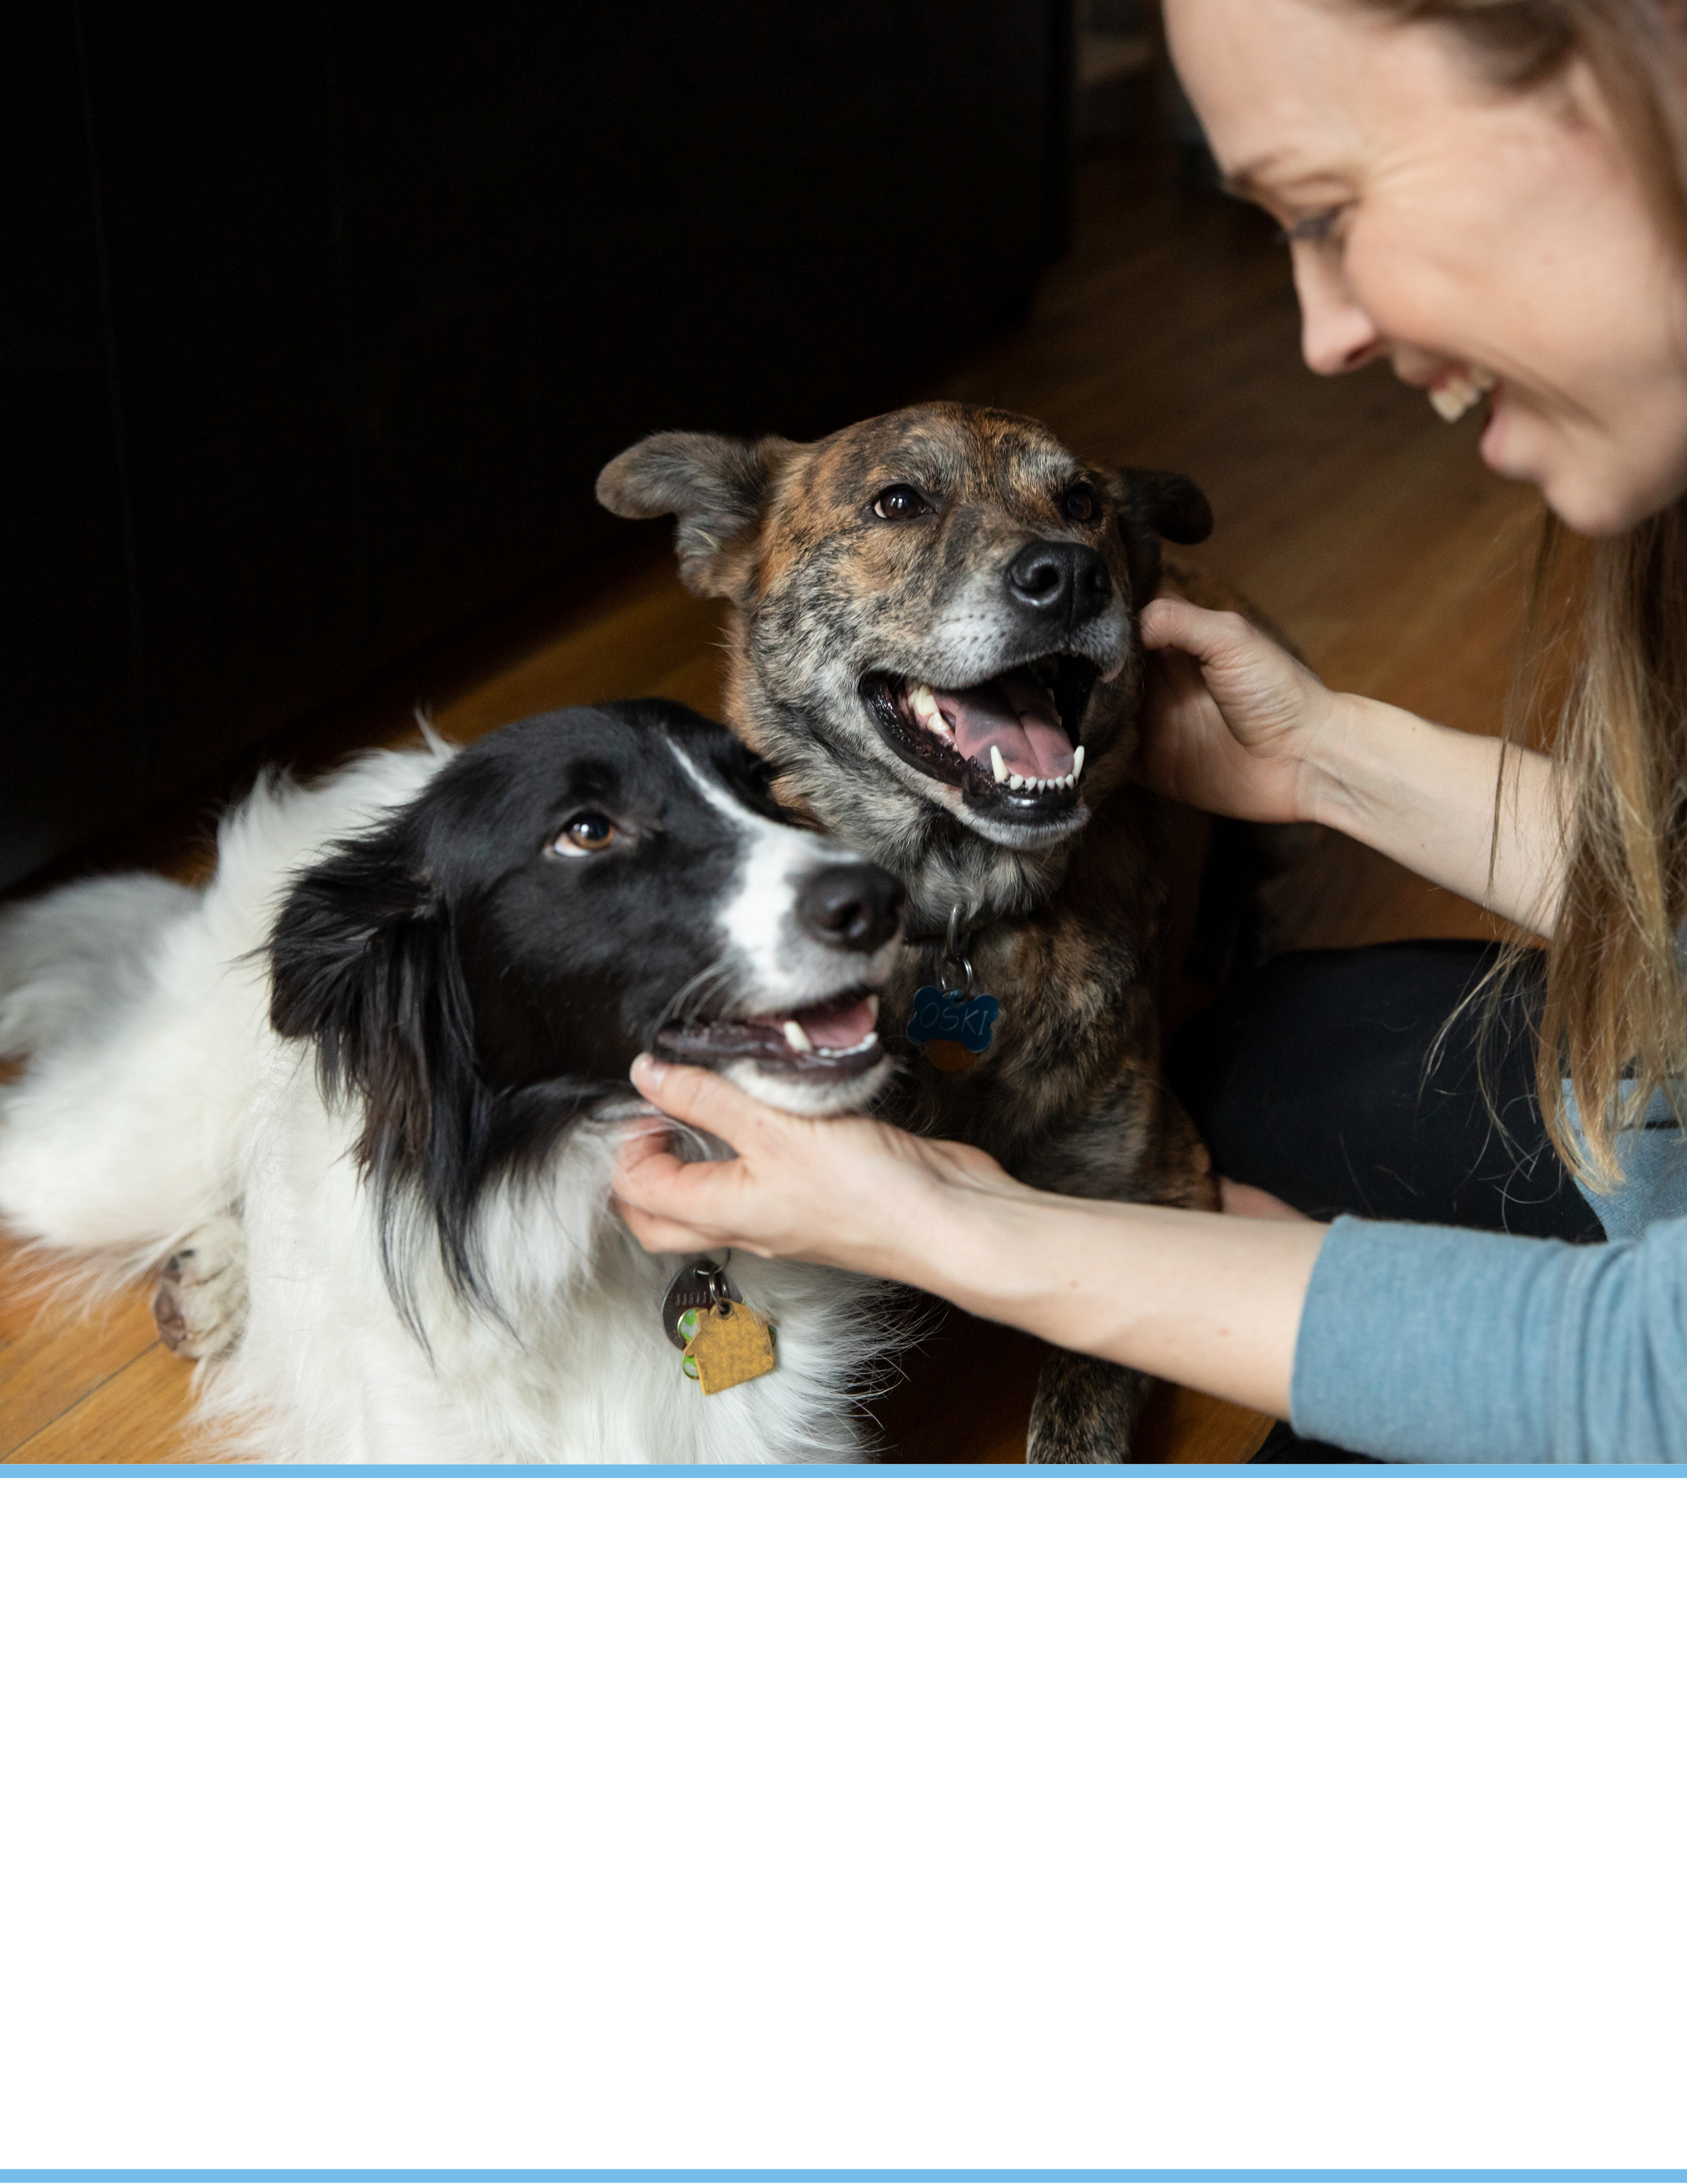

- The Basics (Food, Water, Leash Safety)
- Share the Love
- Tips for a Happy Dog
- Tips for a Successful Transition
- Tips for Building Trust
- Canine DIY Enrichment
- Help Resources
- Dog Body Language
- Tips for Destructive Behavior
ADOPTION RESOURCES
FOR YOUR NEW DOG
Congratulations on Your
Dog Adoption
We know how exciting bringing home a new companion is, and we also know that you might have questions or need support along the way. For basic pet care tips, please visit aspca.org/behavior or call us at XXX-XXX-XXXX.

The Basics
Food: [Organization Name] is part of the [Food Program name]. Your dog/puppy has been eating [type of food] (unless otherwise noted) in the following amounts:

Adult Dogs (over 6 months)  Feed two times daily | Puppies (under 6 months)  Feed three times daily
Canned: | Canned:
Kibble: | Kibble:

If you wish to change the brand of food, we recommend that you purchase another nutritious dog food and introduce it gradually by mixing the current food in with the new food. We also recommend providing food only at mealtimes. Leaving food out for your dog to eat whenever they want can lead to obesity and other diseases.

Water: Provide fresh water in a clean bowl daily. Your dog should have access to the water at all times.

Leash Safety: Your pet is going home with a leash/harness that is best suited for his/her energy level. We recommend you always walk your dog with the leash attached to the equipment provided at the time of adoption. Never allow your dog to be off leash unless they are in a fully enclosed space to avoid them running off or encountering another animal. We also do not recommend taking your new pet to a dog park until you have gotten to know them better.

The Honeymoon Stage: Adopting a new family member is exciting, but there will likely be an adjustment period for both you and your new pet. There may be times when you feel overwhelmed and have second thoughts about your adoption. It’s important to remember that during the transition period, your dog may display behaviors that were not discussed at the time of adoption. It’s normal and to be expected. It may take time for your new pet to adjust to your routine. For example, the dog came from living in a shelter, where walks, meals, and bathroom breaks are at scheduled times, and in your home, that may be different.

If you experience any behavior challenges, we encourage you to journal the behavior and contact us at XXX-XXX-XXXX if you need support. ADD any other support resources organization provides.

Share the Love!

You can join other adopters in our Facebook Alumni group and be sure to celebrate on social media by using the hashtag #OrgHashtag.

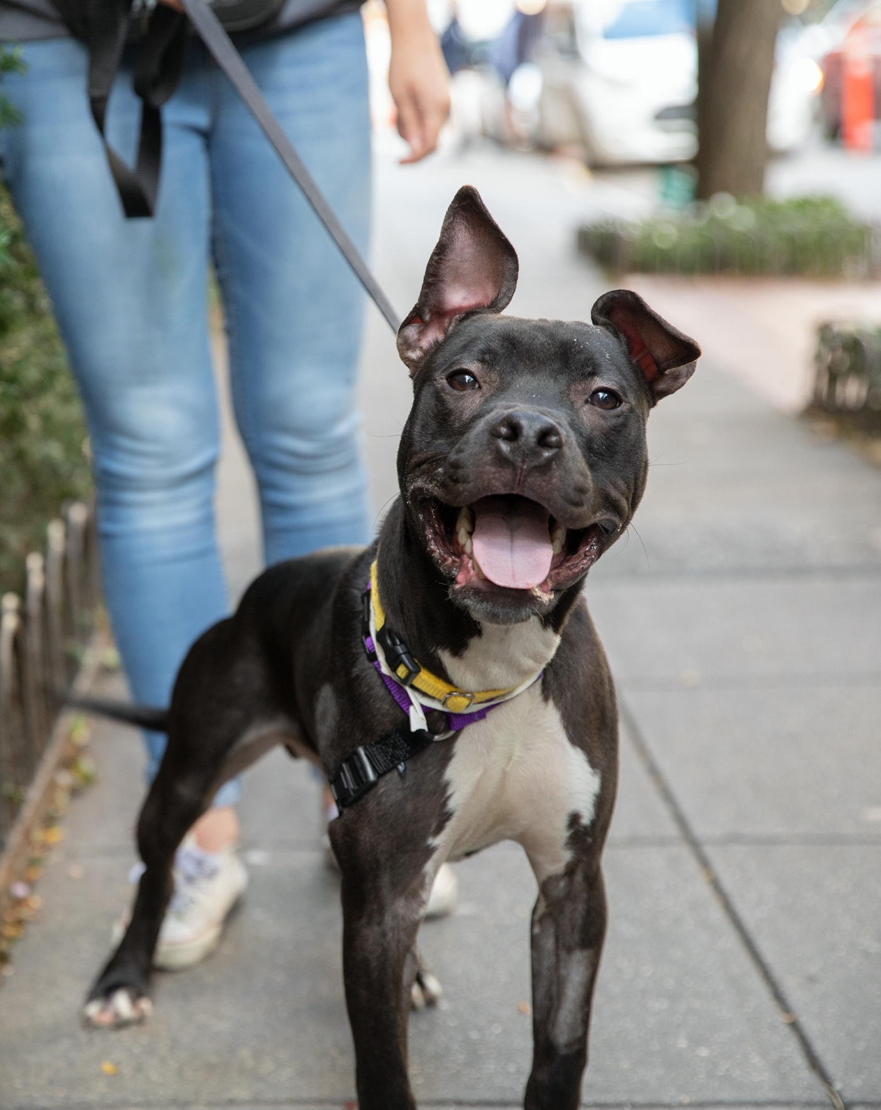
Congratulations on your new family member! Bringing a new dog home is exciting, and the first few days can sometimes be overwhelming. It’s normal to feel regret or frustration. Be patient with yourself and your new pup – even confident dogs need a little support when confronted with change.
Tips for a Happy Dog

Your new pup doesn’t realize they’ve just been upgraded to a great new life – everything is new, likely confusing, and could feel scary. Just like humans, dogs are individuals who each tolerate stress differently. Some dogs quickly transition to new environments, while others need patience and support.

Here are some things that can be stressful to your dog:

- Your pup may not have ever been in a car before
- All the sights, smells, and sounds in and around your
home are new
- Lots of unfamiliar people wanting to greet them
- Not knowing where to relieve themselves

Here are some behaviors you may see during your first few days with your new pup:

- House training accidents
- Inability to settle down (pacing, panting, whining)
- Drinking a lot of water
- Eating very little or not at all
- Barking at noises or movement outside your home
- Lack of interest in interacting with people, other animals, or toys
- Jumping up on counters, beds, or couches
- Following you from room to room/not wanting to be left alone

Tips for a Successful Transition
Tips for a Happy Dog
Having the right setup is key to a smooth transition from shelter to your home. Here are some tips:

- Try not to leave your new pup home alone for the first 48 hours.
- Create a safe space by offering a covered crate with comfortable bedding in a quiet, low-traffic area, such as a bedroom or quiet corner of the living room. This area will give your new dog a place where they can choose to retreat to and watch the action from afar, which can help them feel safe. See this crate training resource to learn how to introduce your dog to a crate.
- Help your pup learn to use the bathroom outside by offering frequent opportunities and rewarding them with a tasty treat when they get it right. See this housetraining resource for more tips.

- Use baby gates to close off areas of the home to which you don’t want your pup to have access or to give your dog personal space if they are overwhelmed by visitors.
- Pick up rugs or any items you don’t want your new pup chewing on or having an accident on.
- Make sure to have plenty of healthy chews and puzzle toys – prepare some ahead of time and put them in the freezer, so they are ready to go when you need to give your new pup something to do. Or check out this enrichment guide to learn how to make your own enrichment at home!
- Put jars of treats in strategic areas of your home so you can reward good behaviors every time you see them. Treats can also be used to “trade” if your new dog grabs something they are not supposed to.

Tips for Building Trust
Dogs, especially shyer dogs, learn to trust their new human friends when they can predict how the person is going to behave. They will avoid new, “unpredictable” people. Predictability helps dogs to settle in, whether it be building a routine or how we behave towards them.

Here are some tips for building a positive, trusting relationship with your new dog:
- Start building a routine by offering meals, walks, and play at similar times each day.
- For walks, start out with walking routes that you plan on taking daily. Allow your new dog plenty of time to sniff on walks so they can get to know their new neighborhood.
- Take plenty of tasty treats on every walk and reward your dog for desired behaviors such as checking in with you, eliminating outside, or walking with a loose leash.
- Wait to have family and friends meet the dog or visit your home until you have built a bond. Unfamiliar people wanting to say hello is often overwhelming for a newly adopted dog.
- Pay close attention to your dog’s body language. How we move and speak to our dogs can impact their stress levels. Familiarizing yourself with canine body language, especially signs of fear, anxiety, and stress will allow you to support your dog. Check out this webinar on speaking dog.
- Be your dog’s advocate when they are scared or nervous. For example, if you notice they seem hesitant or stressed when another dog walks past, the next time a dog walks toward you, try crossing the street and feeding your pup yummy treats.
Tips for a Happy Dog

- If your new dog gets overexcited when the leash comes out and can’t stop jumping on you, calmly scatter some tasty treats on the ground and leash them up while they are eating.
- If you have another dog in your home, keep the dogs separate during mealtimes and supervise when they have access to toys or chews. See our resource on introducing dogs for more tips.
- Wait on nail clippings or baths, as these may be unpleasant or frightening for your new dog.
For dogs that are barking and having a hard time settling down:
- Try minimizing access to the things that are causing them stress. If it’s noises, play some relaxing music, turn on the TV, or use a white noise app on your phone.
- If your pup is barking out the windows, place a shade, temporarily cover the window, or don’t allow the dog in that room.
- Take a deep breath and wait it out. Sometimes time is the best remedy. These behaviors should dissipate after several days of routine.

Canine DIY Enrichment
The key to a happy and healthy dog is regular enrichment and allowing them to engage in their normal behaviors, such as playing, chasing, smelling, chewing, and scavenging. Allowing your dog to engage in these behaviors, satisfies them physically, emotionally, and mentally. Dogs who don’t receive stimulation tend to find ways to enrich themselves, resulting in unwanted behaviors. For great DIY projects that will keep you and your dog entertained, visit aspca.org/pet-care/dog-care/canine-diy-enrichment. These resources include food and environmental enrichment and guides to help you make your own affordable, and easy dog toys and games.
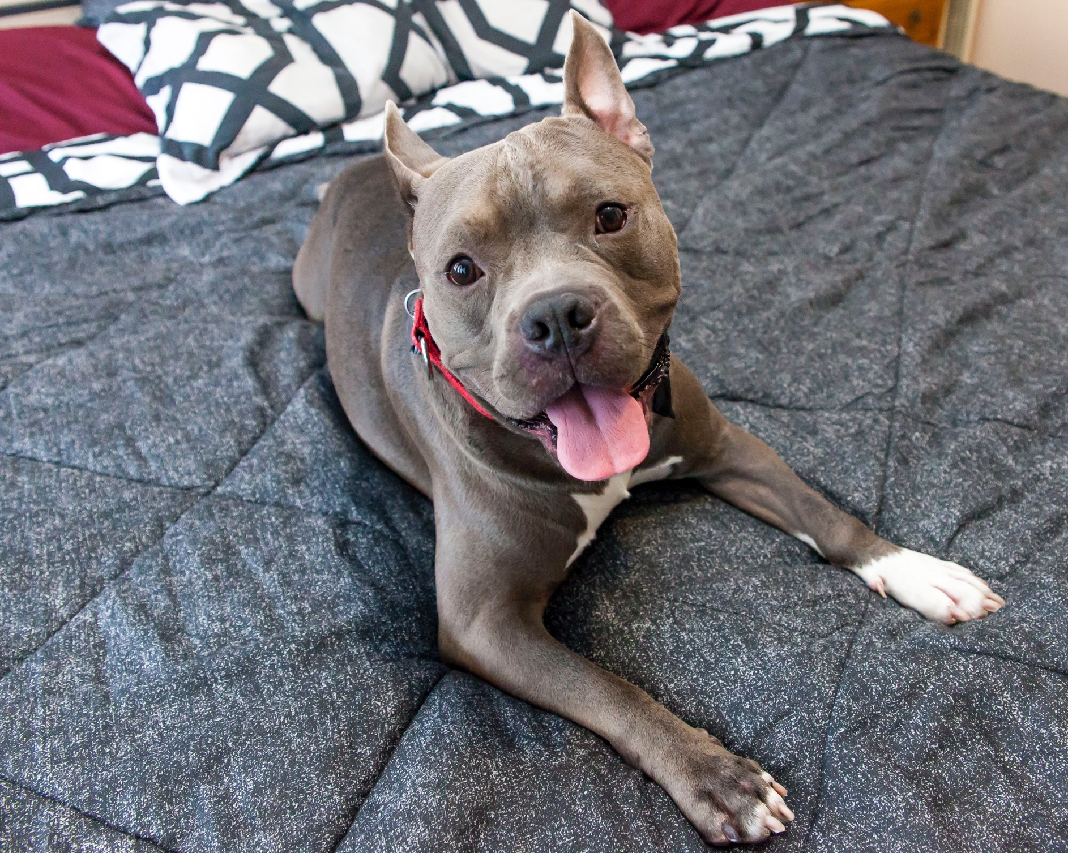
Ask For Help!
If you need support, contact us at INSERT CONTACT EMAIL or PHONE NUMBER.

We understand taking a pet home can come with unexpected challenges, and we are here to support you. If you feel like you need more in-depth guidance, we suggest seeking out the support of a certified professional.

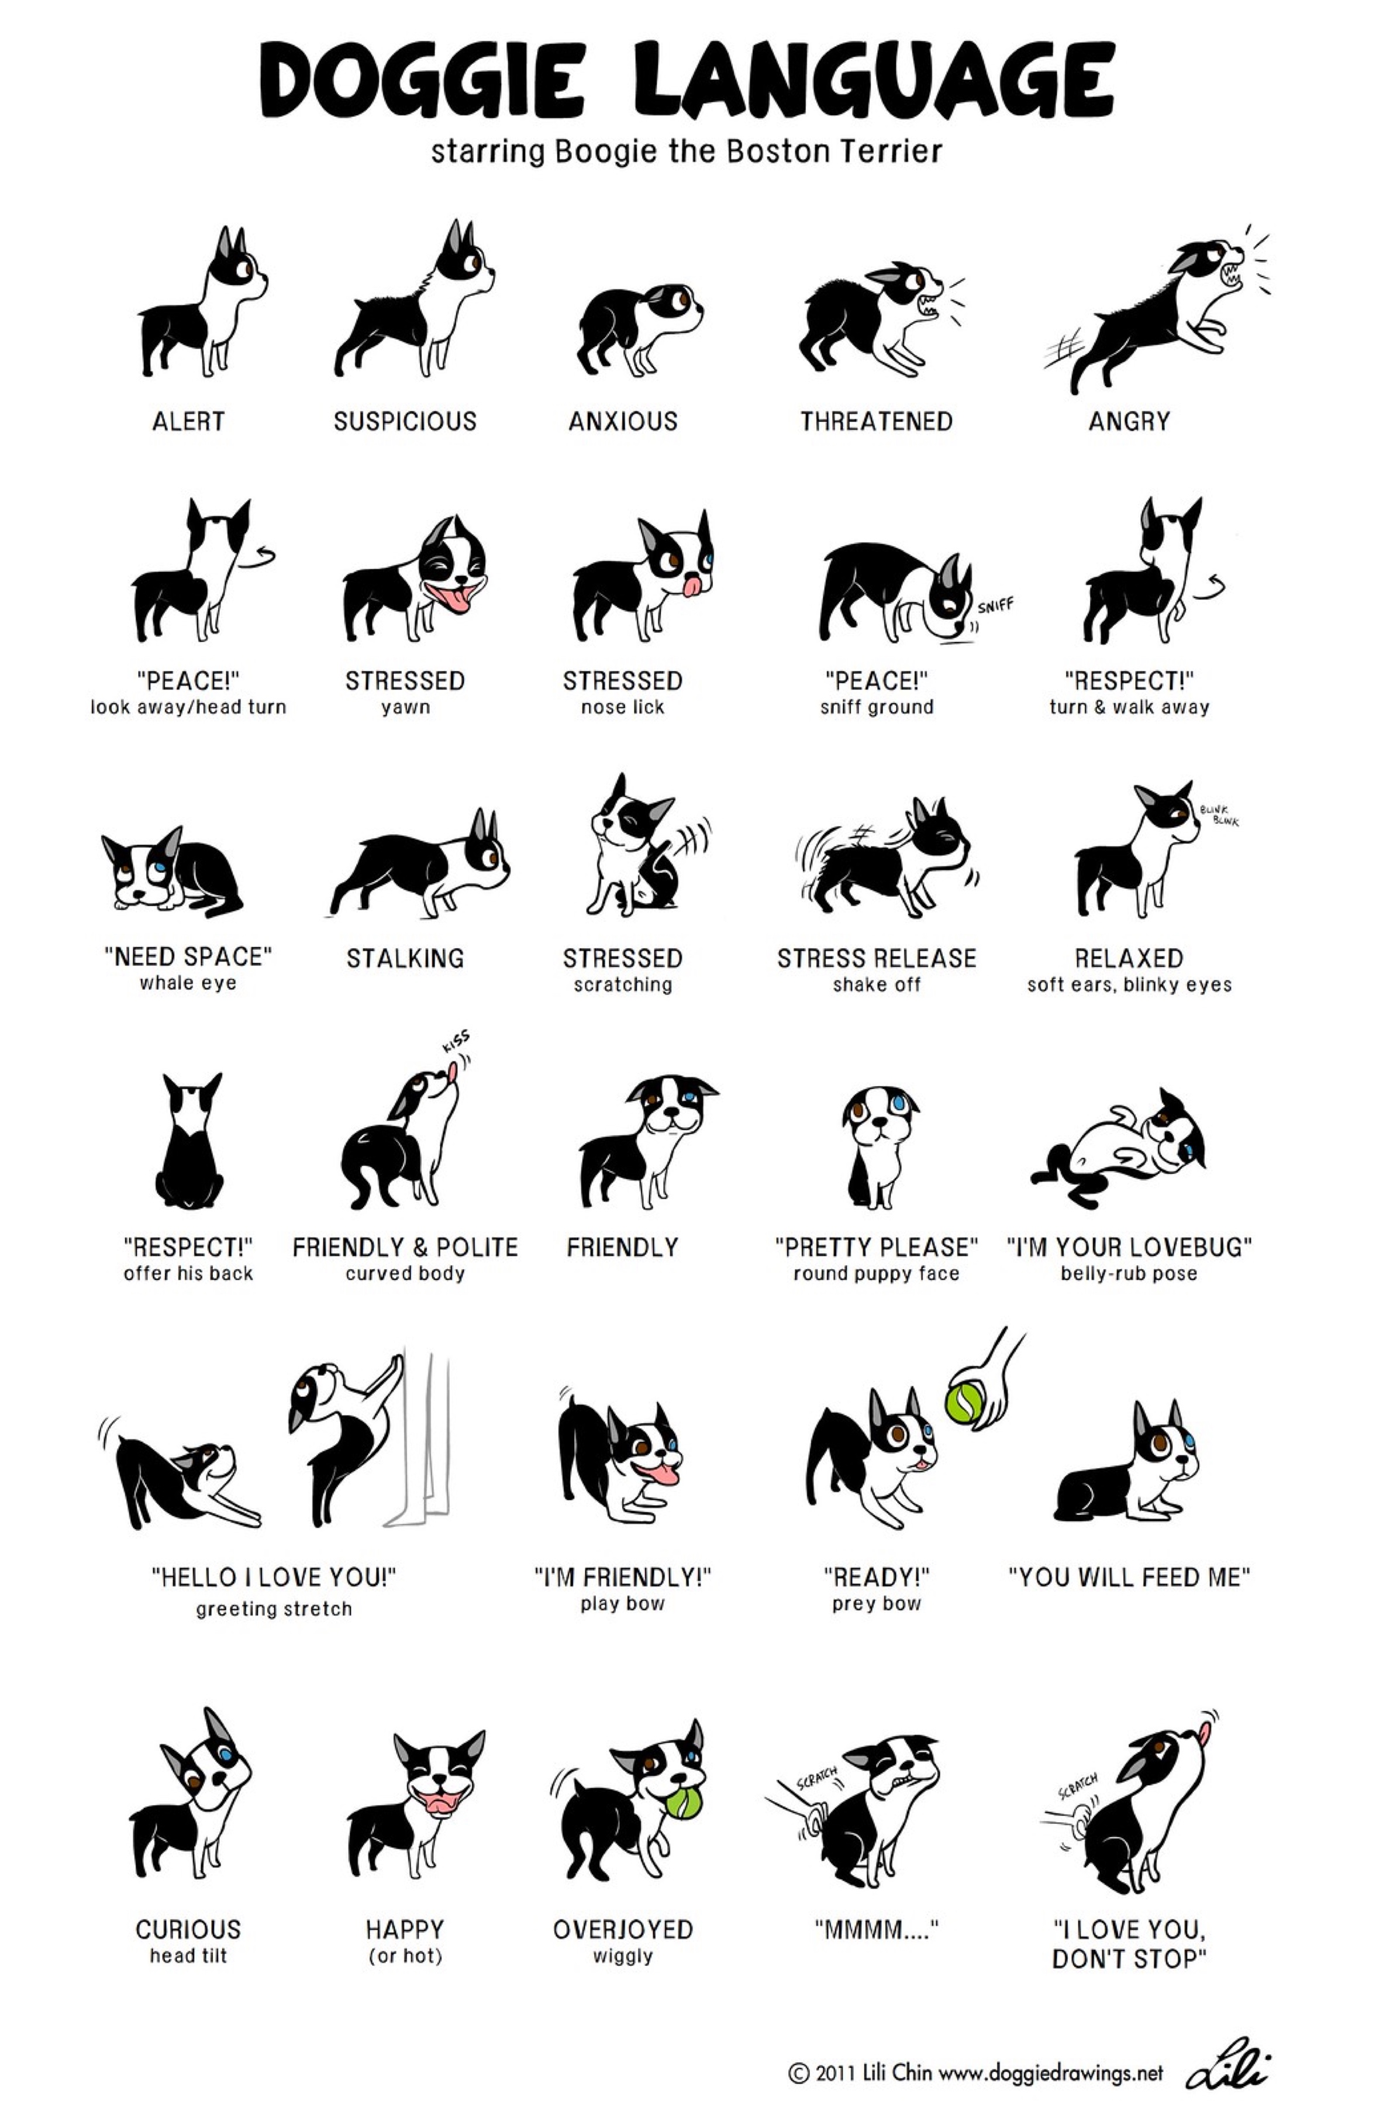
Dog Body Language
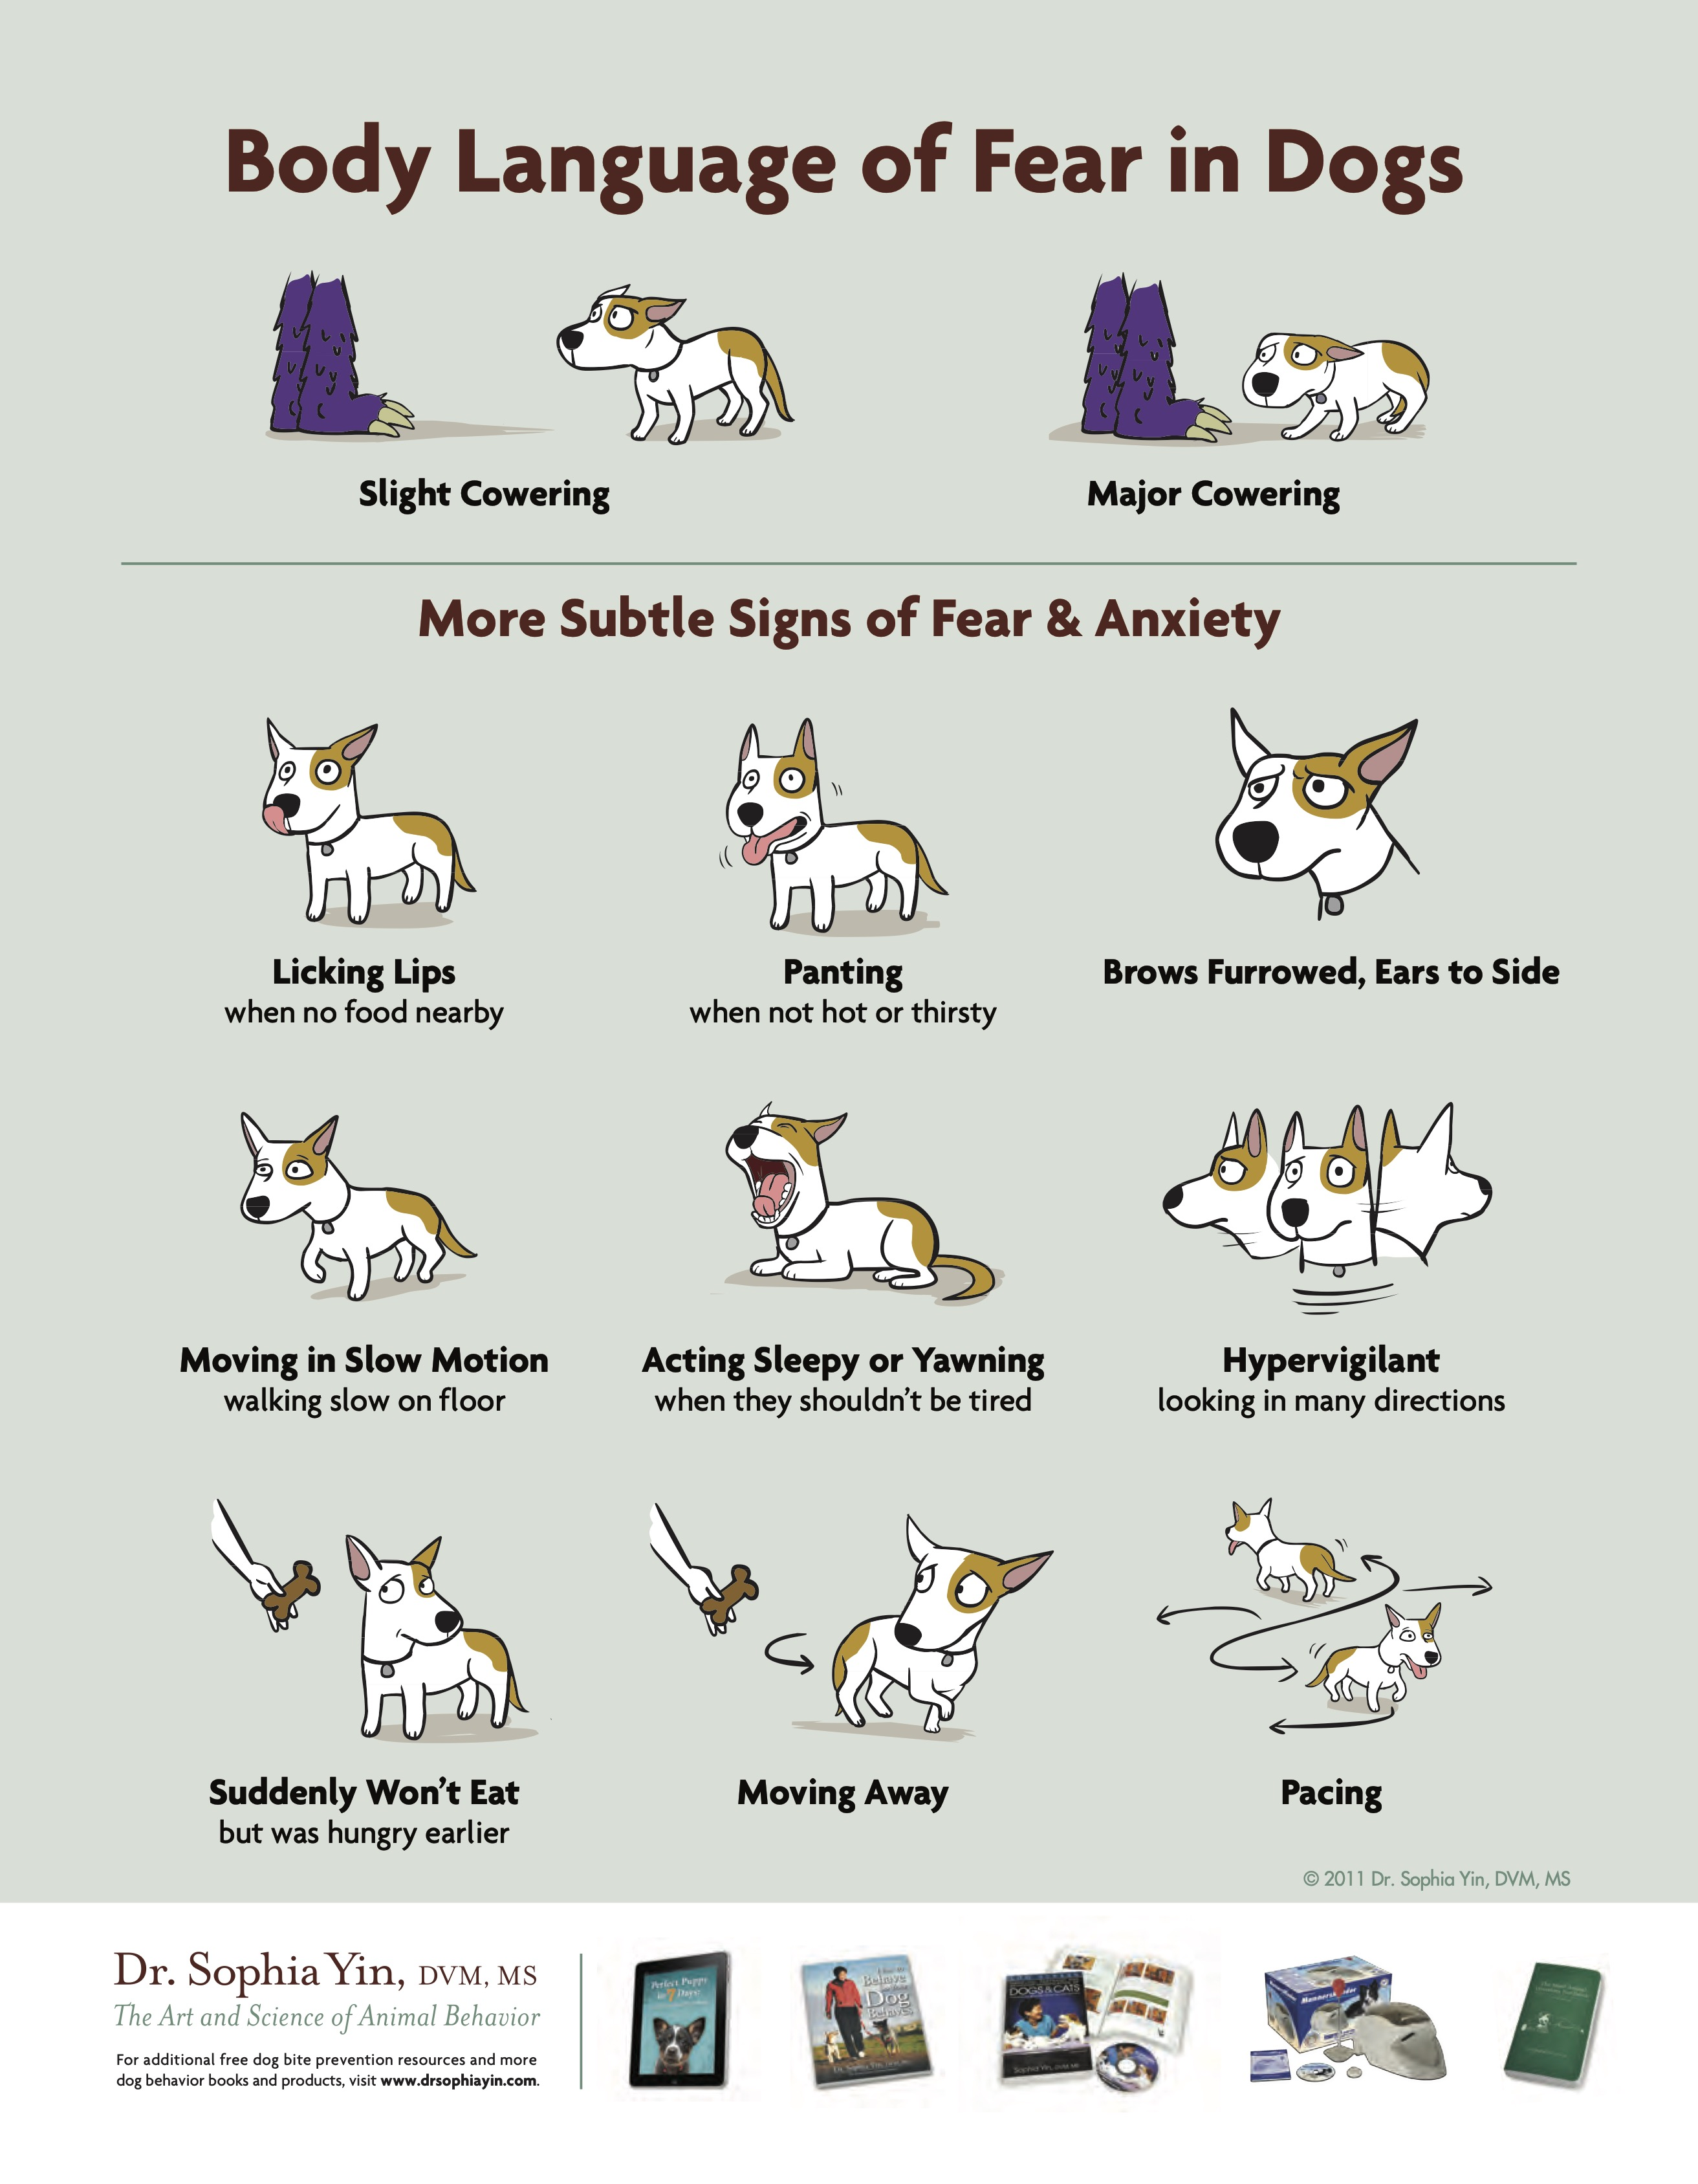
Dog Body Language
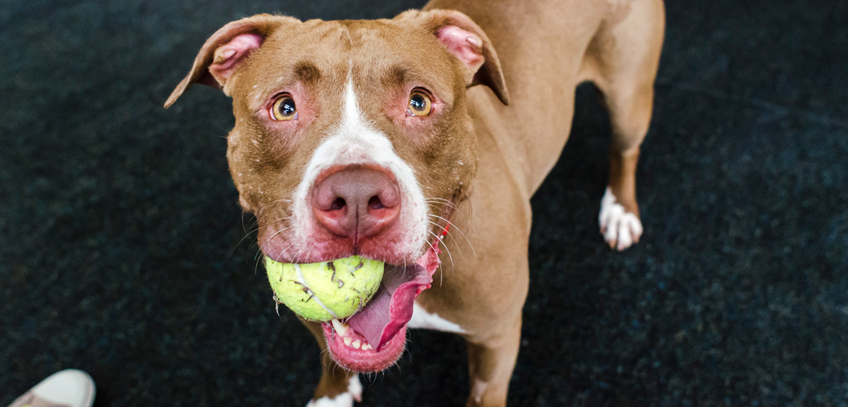
Dealing with Chewing & Destructive Behavior
Chewing is a natural behavior that dogs engage in for a variety of reasons, from boredom to comfort-seeking. Dogs chew as a natural way to clean their teeth and exercise their jaws, while puppies may chew to relieve discomfort from incoming teeth or explore the world around them. Dogs consider any objects they can fit their mouths around as good to chew. As caretakers, it’s up to us to teach them what we consider appropriate to chew by guiding them to appropriate chewing items and discouraging them from chewing things that aren’t.

Provide your dog with appropriate items to chew at all times
Making sure that your dog has easy access to appropriate items to chew will reduce their urge to chew on things you would prefer they don’t. Appropriate items to chew may include hard rubber Kong-like toys or edible chews like marrow bones, knuckle bones, or bully sticks. Be clear and consistent from the beginning regarding what is appropriate and what isn’t, and only provide chewing items that you want your dog to chew on. Do not provide your dog with old running shoes to chew on if you don’t want them also chewing your expensive new shoes! Many dogs prefer to interact with new toys over old, boring toys. Rotating available toys and chews is an easy way to give your dog variety. It also helps the toys to last longer!

If you see your dog chewing an item they should not be, interrupt and provide them with an alternative, appropriate option. Make sure you put the confiscated item away where your dog can’t reach it, so they don’t return to chewing on it! In fact, it’s a good idea in general to prevent access to items you don’t want your dog to chew. Make sure shoes are placed in closets, wires are blocked, and restrict access to areas that may have a lot of tempting items, like bedrooms.

Supervise
Set up your dog for success by supervising them when they are loose in the house. This is especially important for the first few weeks since your new dog is still just learning what you expect! Use crates (make sure your dog is crate trained!) and baby gates when you are unable to supervise to ensure they only have access to appropriate items. That prevents your dog from make chewing mistakes.
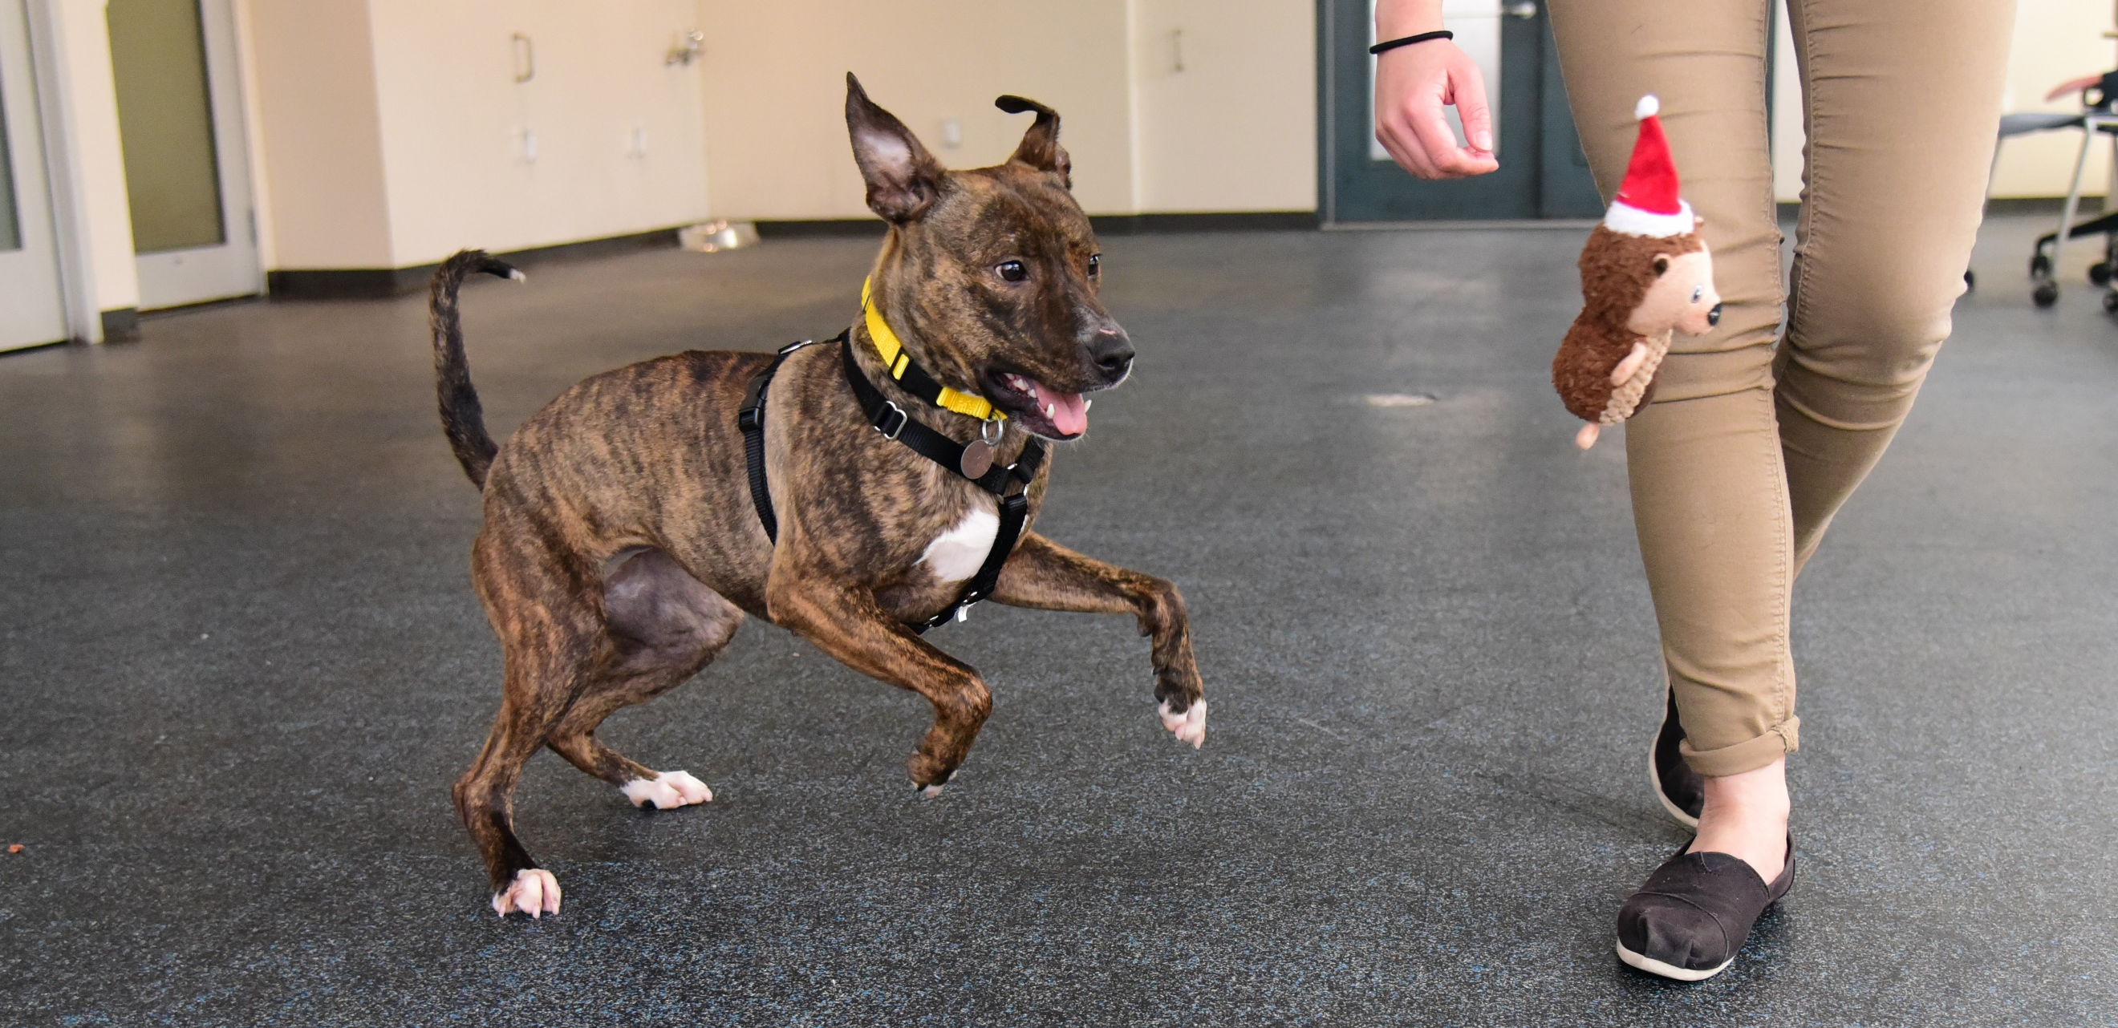
Dealing with Chewing & Destructive Behavior
Exercise
Exercise is important! One reason dogs chew is that they have excess energy to burn. Providing adequate exercise daily will help reduce destructive behavior. Think cardio and remember that some dogs require more exercise than others. Mental exercise and boredom busters are also important. Some dogs chew because they are bored and don’t know what else to do! Providing interactive toys (like stuffed hard rubber chews) also encourages mental stimulation. Spend time teaching your dog new tricks (like sit, down, paw, etc.) every day. This provides mental stimulation for your dog and gives you a fun and different way to interact with your dog. Impress your friends and family with all the different behaviors Your dog can do on command!

Tips
- Provide plenty of appropriate chew items
- Prevent access to inappropriate chew items
- Supervise whenever possible, and confine when supervision isn’t possible
- Provide adequate physical exercise
- Provide mental exercise in the form of training and food dispensing toys (check out these ideas)

