- The Basics (Food, Water, Litterbox)
- Share the Love
- Tips for a Happy Cat (Carriers, Scratching Surfaces, Playtime, DIY Enrichment
- Introducing Your Cat to a New Cat
- Tips for Multi-Cat Households
- Help Resources
- Cat Body Language
ADOPTION RESOURCES
FOR YOUR NEW CAT
Congratulations on Your
Cat Adoption
We know how exciting bringing home a new companion is, and we also know that you might have questions or need support along the way. For basic pet care tips, please visit aspca.org/behavior or call us at XXX-XXX-XXXX.

The Basics
Food: [Organization Name] is part of the [Food Program name]. Your cat/kitten has been eating [type of food] (unless otherwise noted) in the following amounts:

Adult Cats (over 6 months)  Feed two times daily | Kitten (under 6 months)  Feed three times daily
Canned: | Canned:
Kibble: | Kibble:

If you wish to change the brand of food, we recommend that you purchase another nutritious cat food and introduce it gradually by mixing the current food in with the new food. We also recommend providing food only at mealtimes. Leaving food out for your cat to eat whenever they want, can lead to obesity and other diseases.

Water: Provide fresh water in a clean bowl daily. Your cat should have access to the water at all times.

Litter Box: Place an appropriately sized, uncovered litter box with approximately 1-2 inches of litter in a quiet but accessible location. If you have a covered litter box, remove the cover for the first week to allow your cat to get used to the new litter box.

The Honeymoon Stage: Adopting a new family member is exciting, but there will likely be an adjustment period for both you and your new pet. There may be times when you feel overwhelmed and have second thoughts about your adoption. It’s important to remember that during the transition period, your cat/kitten may display behaviors that were not discussed at the time of adoption. It’s normal and to be expected. It may take time for your new pet to adjust to your routine. If you have any questions about your cat’s behavior, we encourage you to keep a journal of the behavior and reach out to us at XXX-XXX-XXXX if you need support. ADD any other support resources organization provides.

Share the Love!

Join other adopters in our Facebook Alumni group and be sure to celebrate on social media by using the hashtag #OrgHashtag.

Take It Slow
Tips for a Happy Cat
Cats can be easily overwhelmed by new spaces, so when you get home, set your cat up in a small quiet room. Keep the door closed. Be sure your cat has access to comfy bedding, hiding spots, toys, food, water, a scratcher, and litterbox. Interact with the cat on their terms –sit a few feet away from them and let them approach you for petting or attention. When the cat is moving around this space confidently, you can begin to slowly introduce them to the rest of your home. Some cats will settle in within a few hours, but most will need a few days or more.

Litter Box
Most cats do best with large, uncovered litter boxes. For kittens or senior cats, be sure the box has lower sides for easy access. Most cats prefer about 1”-2” of unscented litter in the box. Place the box in a quiet area. Cats are more likely to consistently use the litter box when it is kept clean. We recommend you scoop twice a day and perform a full clean every two weeks. Use mild dish soap or a pet-friendly enzymatic cleaner (avoid bleach and other harsh chemicals).

Make Carriers Happy Places
Getting your new cat used to the carrier means vet visits and travel will be much easier–and it’s super easy to do! Just set the carrier up in a spot where your cat or kitten likes to hang out and keep it out all the time. Prop the door open, place some comfy bedding inside, and feed a treat in the carrier at least once a day. You can also use play to get your cat running in and out of the carrier. If your cat rests in their carrier regularly, mission accomplished!

Scratching Surfaces
Cats have a need to scratch, so be sure to provide plenty of cat-friendly scratching surfaces. Most cats enjoy both horizontal cardboard scratchers and scratching posts (for posts, pick one that is sturdy and tall enough for your cat to get a good stretch). Reward your cat with treats and praise when they use their scratchers.

Daily Interactive Playtime
Playing with your cat is a great way for you to bond and help them feel less stressed. Cats love chasing, pouncing on, and leaping after wand toys. Keep play interesting by having a couple of different wand toys on daily rotation. When using wand toys, allow your cat to “catch” the toy a few times during play and end playtime with a yummy treat. A good play session can last from 10 to 15 minutes. Always use toys during play, and not your hands or feet. If your cat tries to play with hands or feet, become a statue by folding your arms and looking away and wait a few minutes before giving any more attention. Avoid petting or picking up during or directly after playtime.

Feline DIY Enrichment
Enrichment is essential for cats and kittens of all ages and keeping your cat’s environment as exciting and stimulating as possible will promote a happy and healthy life. Check out these great DIY projects that will keep you and your cat entertained. These resources include food and environmental enrichment guides to help you make your own fun and affordable cat toys.
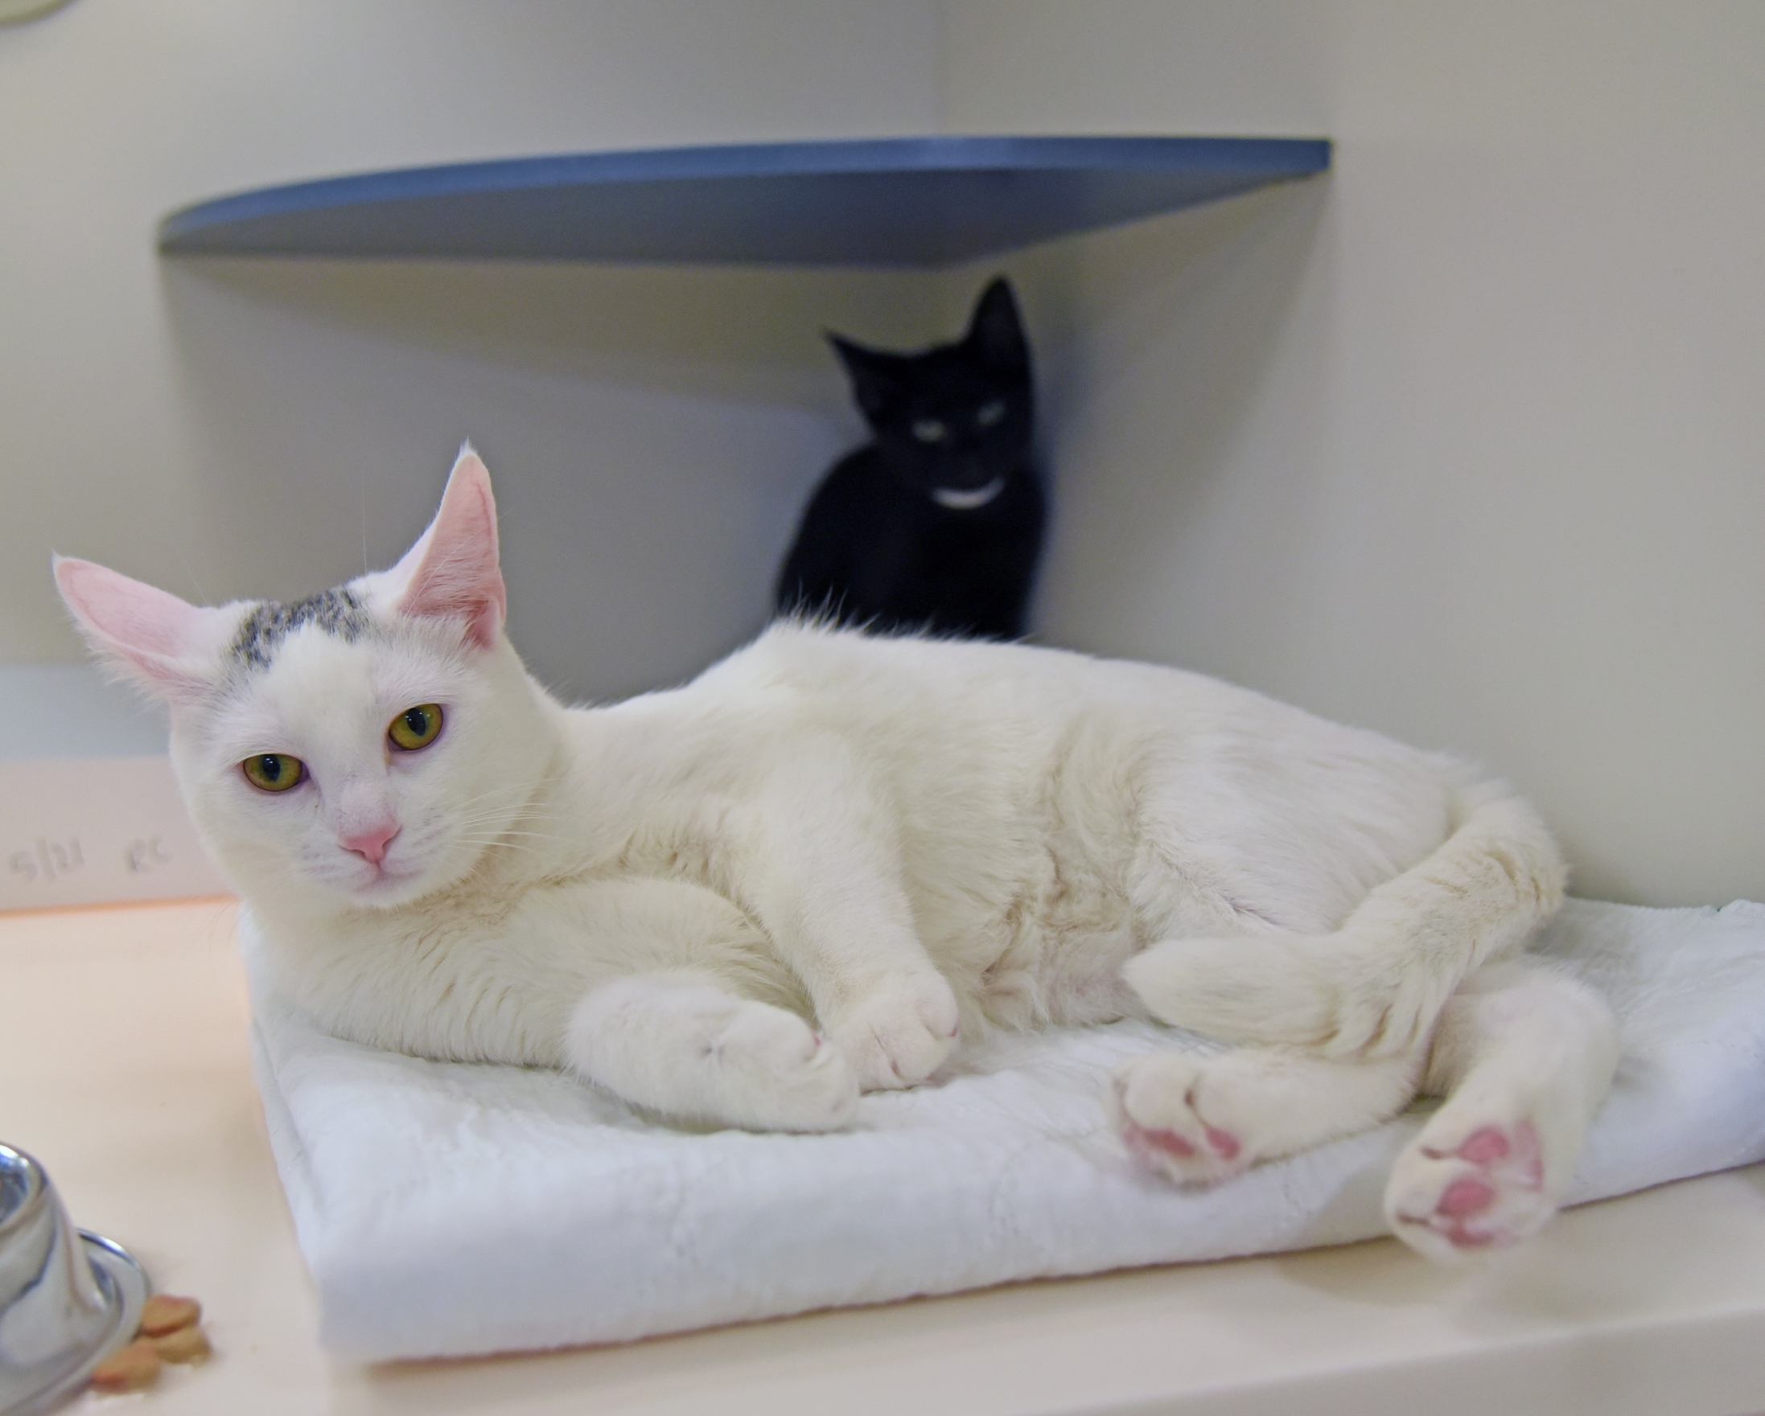
If you’re bringing a new cat into your home, the most important thing is to be patient. The introduction between two cats must be gradual and keep in mind it can take a long time for a relationship to grow. The first impression a new cat makes when they meet your resident cat is critical. If two cats display aggression during their first meeting, this may set the mood for their future relationship.
Introducing Your Cat
to a New Cat

If your resident cat becomes aggressive when they see other cats outside your home, you’ll probably have a difficult time introducing a new cat into your household. If your cat has lived harmoniously with other cats in the past, the odds are good that they will adjust to a newcomer. However, it is generally not possible to predict whether any two individual cats will get along.

To set them up for success, be patient and follow these steps:

Step 1: Keep the Cats Separated
Just before you bring your new cat home, confine your resident cat to one room so the cats are unable to see each other. Do not give your resident cat an opportunity to approach the new cat in their carrier. This can be extremely frightening for the new cat.

Bring your new cat directly into their own quiet room. Be sure the door to this room stays closed. This will allow the two cats to smell and hear—but not see or touch—each other. This helps reduce stress by not overwhelming either cat with too much change too quickly.

Each cat should have essential items within their respective spaces: food, water bowl, litter box, scratching post, and places to hide (cardboard boxes make for easy and inexpensive hiding spots). Do your best to avoid changing your resident cat’s environment and routine as much as possible: keep the same feeding schedule, avoid moving resources such as litter boxes or scratching posts, and give them plenty of your attention.

During this period of separation, teach the cats to associate each other’s scent with positive experiences:

- Feed the cats treats near the door that separates them so they learn that coming together (even though they can’t see each other) results in a pleasant experience.

- Offer each cat something that smells like the other cat, such as bedding or a towel rubbed on each cat’s head and cheeks. Place a treat on the bed or towel to help the cats make a positive association with the other cat’s smell.

- Play with each of the cats near the door. Encourage them to paw at toys under the door. Eventually the cats may play “paws” under the door with each other.

- If your resident cat is not showing signs of stress and your new cat is exploring confidently, eating well, and using the litter box, switch the cats’ locations so they can investigate each other’s smell. This also allows your new cat to explore a different section of your home.
Step 2: Let the Cats See Each Other
Introducing Your Cat
to a New Cat
Only move onto this step if there are no signs of aggression (hissing, growling), both cats are eating well, using their litter box, and otherwise not showing any signs of illness or stress. Remember to take it slow! You are helping the cats to build a relationship that will continue to develop over time; there is no need to rush them--different cats go at different paces.

Before you start, decide if you will use a baby gate for this step or just crack the door open slightly. Your goal is to allow the cats to see each other, but not interact. If you use a gate, be sure it is securely in place before opening the door. Use this method with caution because a cat can easily jump over even a tall gate.

- If possible, have a friend or family member help, where one cat and one person are on each side of the door. Give each cat a play session followed by a meal before you start.

- Allow the cats to see each other. When either cat notices the other, offer that cat a tasty treat or play with a favorite toy. Do not force the cats to come closer to one another. It is important that the introduction goes at their pace.

- Avoid petting or holding either cat during these sessions. Being petted or handled can inadvertently cause stress and they could accidentally scratch you.

- Let the cats see each other for just a few minutes and end each session while both cats are still relaxed. Continue to keep the cats fully separated between these sessions.

- Over the next few days, continue to feed meals, offer treats, and play with the cats near the barrier. Gradually lengthen the amount of time the cats see each other.

Step 3: Let the Cats Spend Time Together
Hold off on this step until the cats are completely relaxed during step 2 and show no signs of conflict or aggression. Supervise these initial face-to-face interactions carefully and keep the interactions short at first.

- It is a good idea to play with each cat while they can see each other behind the barrier, feed them a meal, and then remove the barrier. This is so that both cats are feeling calm when they spend time together.

- Start with just a few minutes at a time, gradually increasing the time they spend together over several sessions. Carefully observe both cats for signs of stress and do not force them to approach each other.

- As the cats become more comfortable with each other, allow them longer and longer periods of time together.

- Keep a large towel handy just in case the cats begin to fight. If they do fight, do not touch them! Use the towel to block them from seeing one another, then lure them away from each other. Go back to step 2 for about another week, then try removing the barrier again.

Additional Tips for Keeping the Peace in a Multi-Cat Household
Introducing Your Cat
to a New Cat
- Your cats will be more likely to get along if they’re happy in their environment. Look at the layout of your home. Make sure there are always plenty of hiding spots for your cats. Some like to sit up high, on shelves or perches, while others tend to hide under and behind things, so make sure you provide hiding spots at floor level as well.

- Offer at least the same number of litter boxes as there are cats, but ideally one more (so if you have three cats, offer them all access to at least three litterboxes, but four is better). The litter boxes should be located in different areas of the home as instead of side by side.

- Offer multiple scratching posts, resting/hiding spots, water bowls, feeding stations, and perches in different locations. When cats must compete for resources, it can increase the potential for conflict. It is especially important that food, water, and litter boxes are placed out in the open so your cats don’t feel trapped or vulnerable when they access these resources.

- In addition to a well-designed home environment with plenty of access to resources, consider using a pheromone therapy called Feliway Multi-Cat. Available as a diffuser, this product is a copy of the feline appeasing pheromone mother cats produce during lactation and can provide a calming effect among the cats in your home.

- If you’re bringing a new cat into a household with multiple cats, introduce each resident cat to the newcomer individually. After each of your cats has met the new cat one-on-one and absent any signs of stress or aggression, you can start to allow all the cats to mingle as a group.

- When returning from a vet visit, even if just one of your cats went to the vet, it is always a good idea to keep the cats in separate rooms for at least a day. Smell is a key form of communication for cats and the smell of the vet’s office can be interpreted as threatening.

- If one cat spends most of their time hiding or one cat continuously bullies the other cat, reach out for help (see below for our contact information or look for a certified professional). These types of interactions can cause other behavioral issues, such as litter box accidents, and the longer these behaviors happen, the harder they can be to fix.

ASk For Help
If you need support, contact us at INSERT CONTACT EMAIL or PHONE NUMBER.

We understand taking a pet home can come with unexpected challenges and we are here to support you. If you’ feel like you need more in-depth guidance, we suggest seeking out the support of a certified professional.

Cat Body Language
Cat Body Language

