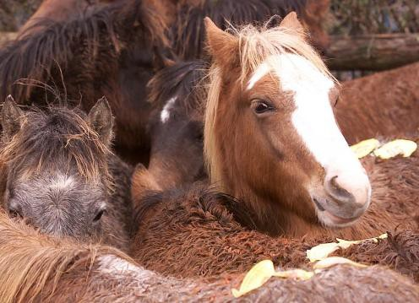
What is Horse Slaughter?

Ever year over 100,000 American horses are commercially slaughtered for human consumption in other countries. Americans do not eat horsemeat -- this grisly, profit-driven industry is based solely on foreign demand. Although horse slaughter plants previously existed in the United States, none presently operate—however, horses are transported in tightly packed trailers to slaughter plants in Mexico and Canada. This gruesome industry typically preys upon young, healthy horses that may come from any background. Champion racers, accomplished show jumpers, ranch horses and children’s ponies have all been victims of horse slaughter.

Why Oppose Horse Slaughter?

Animal Cruelty
Horse slaughter is especially inhumane because horses, skittish by nature, are extremely difficult to properly render unconscious before slaughter. They often endure repeated blows to the head and, shockingly, may sometimes be awake during the butchering process. The United States Department of Agriculture (USDA) inspectors cited rampant cruelty violations at plants previously operating in the U.S. Additionally, cramped and long-distance transport to plants results in cruelty and neglect. Even when U.S. plants operated, the average distance a slaughter-bound horse traveled was
550 miles, often with little food, water and rest.

Strong Public Opposition
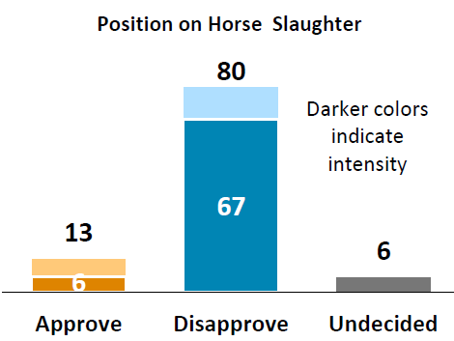
A 2012 national poll revealed that 80% of Americans favor a ban on horse slaughter and recognize our responsibility to protect these intelligent, sensitive animals from slaughter. Horses are companions with a historically significant role in American culture. We owe them a kinder, more dignified end of life than to be cruelly slaughtered and served up on foreign dinner plates.

Food Toxicity
American horses are not raised for food production. During their lives, they are routinely given hundreds of drugs and other substances (legal and illegal, and) that have not been approved by the FDA for use in animals intended for human consumption due to dangerous toxicity concerns. There is no system in the U.S. for tracking the lifetime medical histories of American horses.

Bad Market
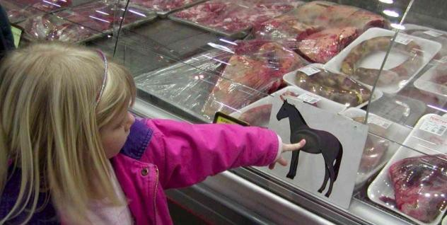
The 2013 discovery of horsemeat in mislabeled beef products in the U.K. and the European Union (EU)—and the resulting 30-43% drop in sales of ready-made and frozen meat products in those countries—forecasted the threat to public health and consumer confidence in food industries that horse slaughter can cause. In 2015, the EU suspended horsemeat imports from Mexico due in large part to food safety and cruelty concerns about American horses slaughtered in Mexican plants.

Damage to Communities
The horrific stories of communities burdened by former horse slaughter plants tell the story -- these facilities
inflict environmental damage, drain local economies, and diminish property values. The minimal number of low- paying, dangerous jobs that the plants offer cannot compensate for the enormous environmental and financial burdens placed on surrounding communities.

Options Are Available
More than 92% of American horses sent to slaughter are in good condition. Most would have been able to live productive lives if given the chance. But slaughter
buyers regularly attend and outbid legitimate horse owners and rescues at auctions. Additionally, allowing slaughter encourages irresponsible breeding practices. The U.S. is home to nearly 700 equine rescues, 600 program organizations that accept donated horses, countless horse owners, gelding clinics and hay banks
that can provide alternatives to slaughter for our horses.
Humane euthanasia is a merciful last resort so that no horse’s final moments need be spent on a grisly slaughter plant floor.

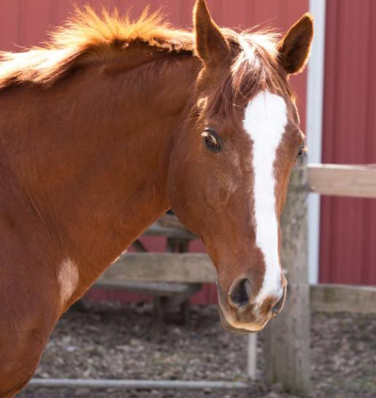
How Do We End Horse Slaughter?

Because horse slaughter is an unnecessary business, driven by profit and demand, the only way to end it is to make the practice illegal in the United States. Congress is considering two options to achieve this end.

A full, permanent federal ban is needed to stop horse slaughter once and for all. The Safeguard American Food Exports Act (SAFE Act) would prohibit the sale of horsemeat for human consumption in the U.S. and the export of horses for that purpose abroad. The ASPCA is working fervently to gain support and passage of this bill in Congress.

Until a full federal ban is enacted, we must keep horse slaughter from regaining a presence in the U.S. To that end, the ASPCA is working to insert into the annual USDA spending bill a horse slaughter funding ban provision that prohibits the
use of tax dollars for food safety inspections of horsemeat. Because plants must be
inspected in order to operate, this funding ban keeps plants from opening in the U.S. However, because the Agriculture Appropriations bill that includes this language expires at the end of each fiscal year, we must repeat the push for inclusion of the horse slaughter funding ban every year.

What Can I Do to Help?

1. Lobby your Members of Congress to protect horses.
Every American citizen is represented by 2 U.S. Senators and 1 U.S. Representative in Congress—and anyone can be an effective, influential citizen lobbyist! Visit www.aspca.org/LookUp to identify your members of Congress and learn how to contact them. Then start a relationship with them, and ask them to support the SAFE Act. If your legislator sits on the Appropriations committee, urge him or her to support the horse slaughter defunding provision as well. There are many ways to lobby and maintain a relationship with your legislators:
➢ Send an email
➢ Make a phone call
➢ Meet in person (either in D.C. or at home at a town hall event or their local office)
➢ Visit their websites and sign up for their newsletters

2. Vote with horse protection in mind at election time. An easy way to help equine-friendly legislation is to elect lawmakers who will support that legislation.

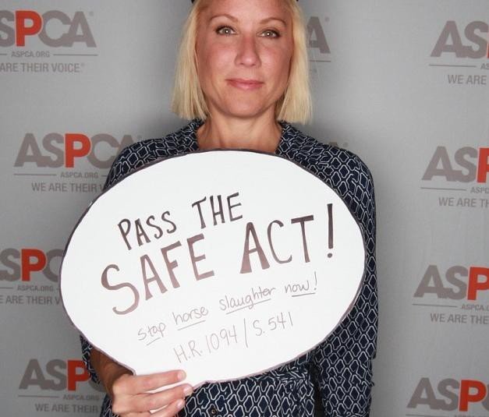
3. Write letters to the editor of your local newspapers about horse slaughter. Educate your community, rally others to form a coalition of like-minded advocates, and publicly praise lawmakers who take positive steps on behalf of horse protection. Letters to the editor are a key way to get media attention and build momentum on behalf of a cause.

4. Join the ASPCA Advocacy Horse Action Team.
Go to www.aspca.org/horseactionteam to sign up to receive our updates on urgent legislative issues regarding horses, including upcoming votes, co-sponsorship needs, outreach to legislative offices and Town Hall notices. This is a great way to help horses and our advocacy team will help you each step of the way!

